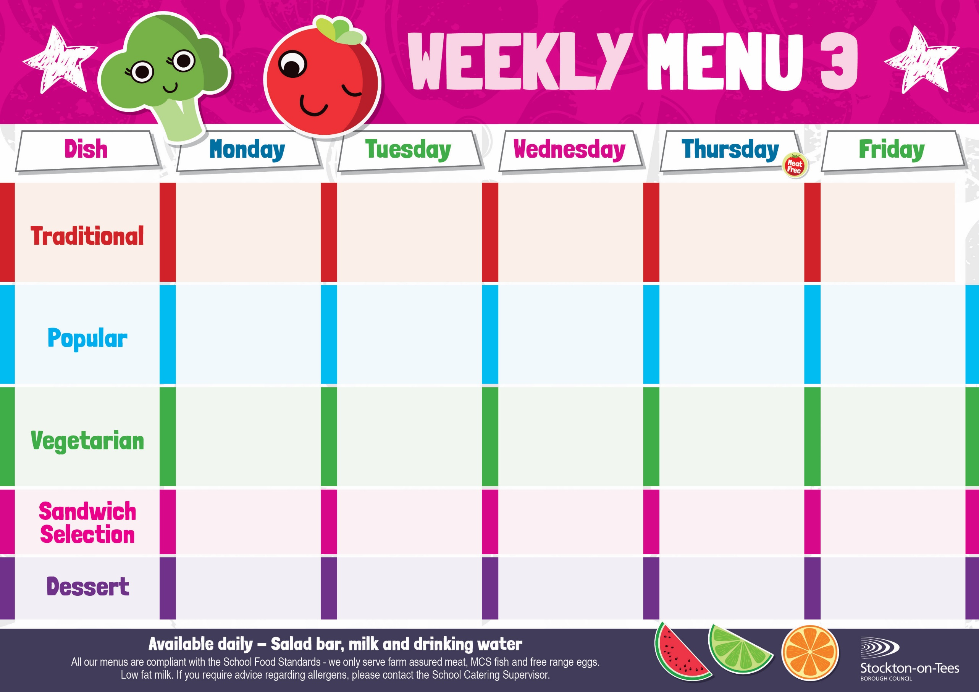
Macaroni Cheese
Homemade Garlic Bread
Cauliflower & Green Beans

Egg Mayonnaise

Roasted Potatoes
Weeks beginning 14 September, 5th October, 26th October, 16th November & 7th December, 2026

Fish Fillet Fingers
Oven Baked Chips
Mushy Peas &
Baked Beans
Vegan Sausage Roll
Potato Wedges
Sweetcorn
Sausage Roll
Potato Wedges
Sweetcorn
Choc Chip Sponge &
Custard Sauce
Cup Cake
Homemade Biscuit &
Yoghurt
Minced Quorn & Dumplings
Creamed Potatoes
Cauliflower & Green Beans

Minced Beef & Dumplings
Creamed Potatoes
Cauliflower & Green Beans

Lasagne
Homemade Garlic Bread
Sweetcorn

Homemade Quiche
Potato Waffles
Garden Peas

Baked Quorn Sausages
Oven Baked Chips
Mushy Peas &
Baked Beans

Vegan Dippers
Potato Waffles
Garden Peas

Vegetable Fingers
Roasted Potatoes
Baked Beans

Homemade Pizza Whirls
Oven Baked Chips

Baked Beans

Roast Ham
Potato Wedges

Cheese
Potato Waffles
Decorated Iced Sponge &
Custard Sauce
Ice Cream
Homemade Biscuit &
Fresh Fruit

Chocolate Crunch &
Custard Sauce
Fruity Muffin
Homemade Biscuit &
Yoghurt

Syrup Roly Poly & Custard Sauce
Jelly
Homemade Biscuit &
Fresh Fruit

Jam Sponge &
Custard Sauce
Fruity Cookie
Homemade Biscuit &
Fresh Fruit
Tuna Mayonnaise
Roasted Potatoes
Tuna Mayonnaise
Oven Baked Chips
Breaded Chicken Breast Fillet
Potato Waffles
Garden Peas

Baked Sausages
Roasted Potatoes
Mushy Peas &
Baked Beans

