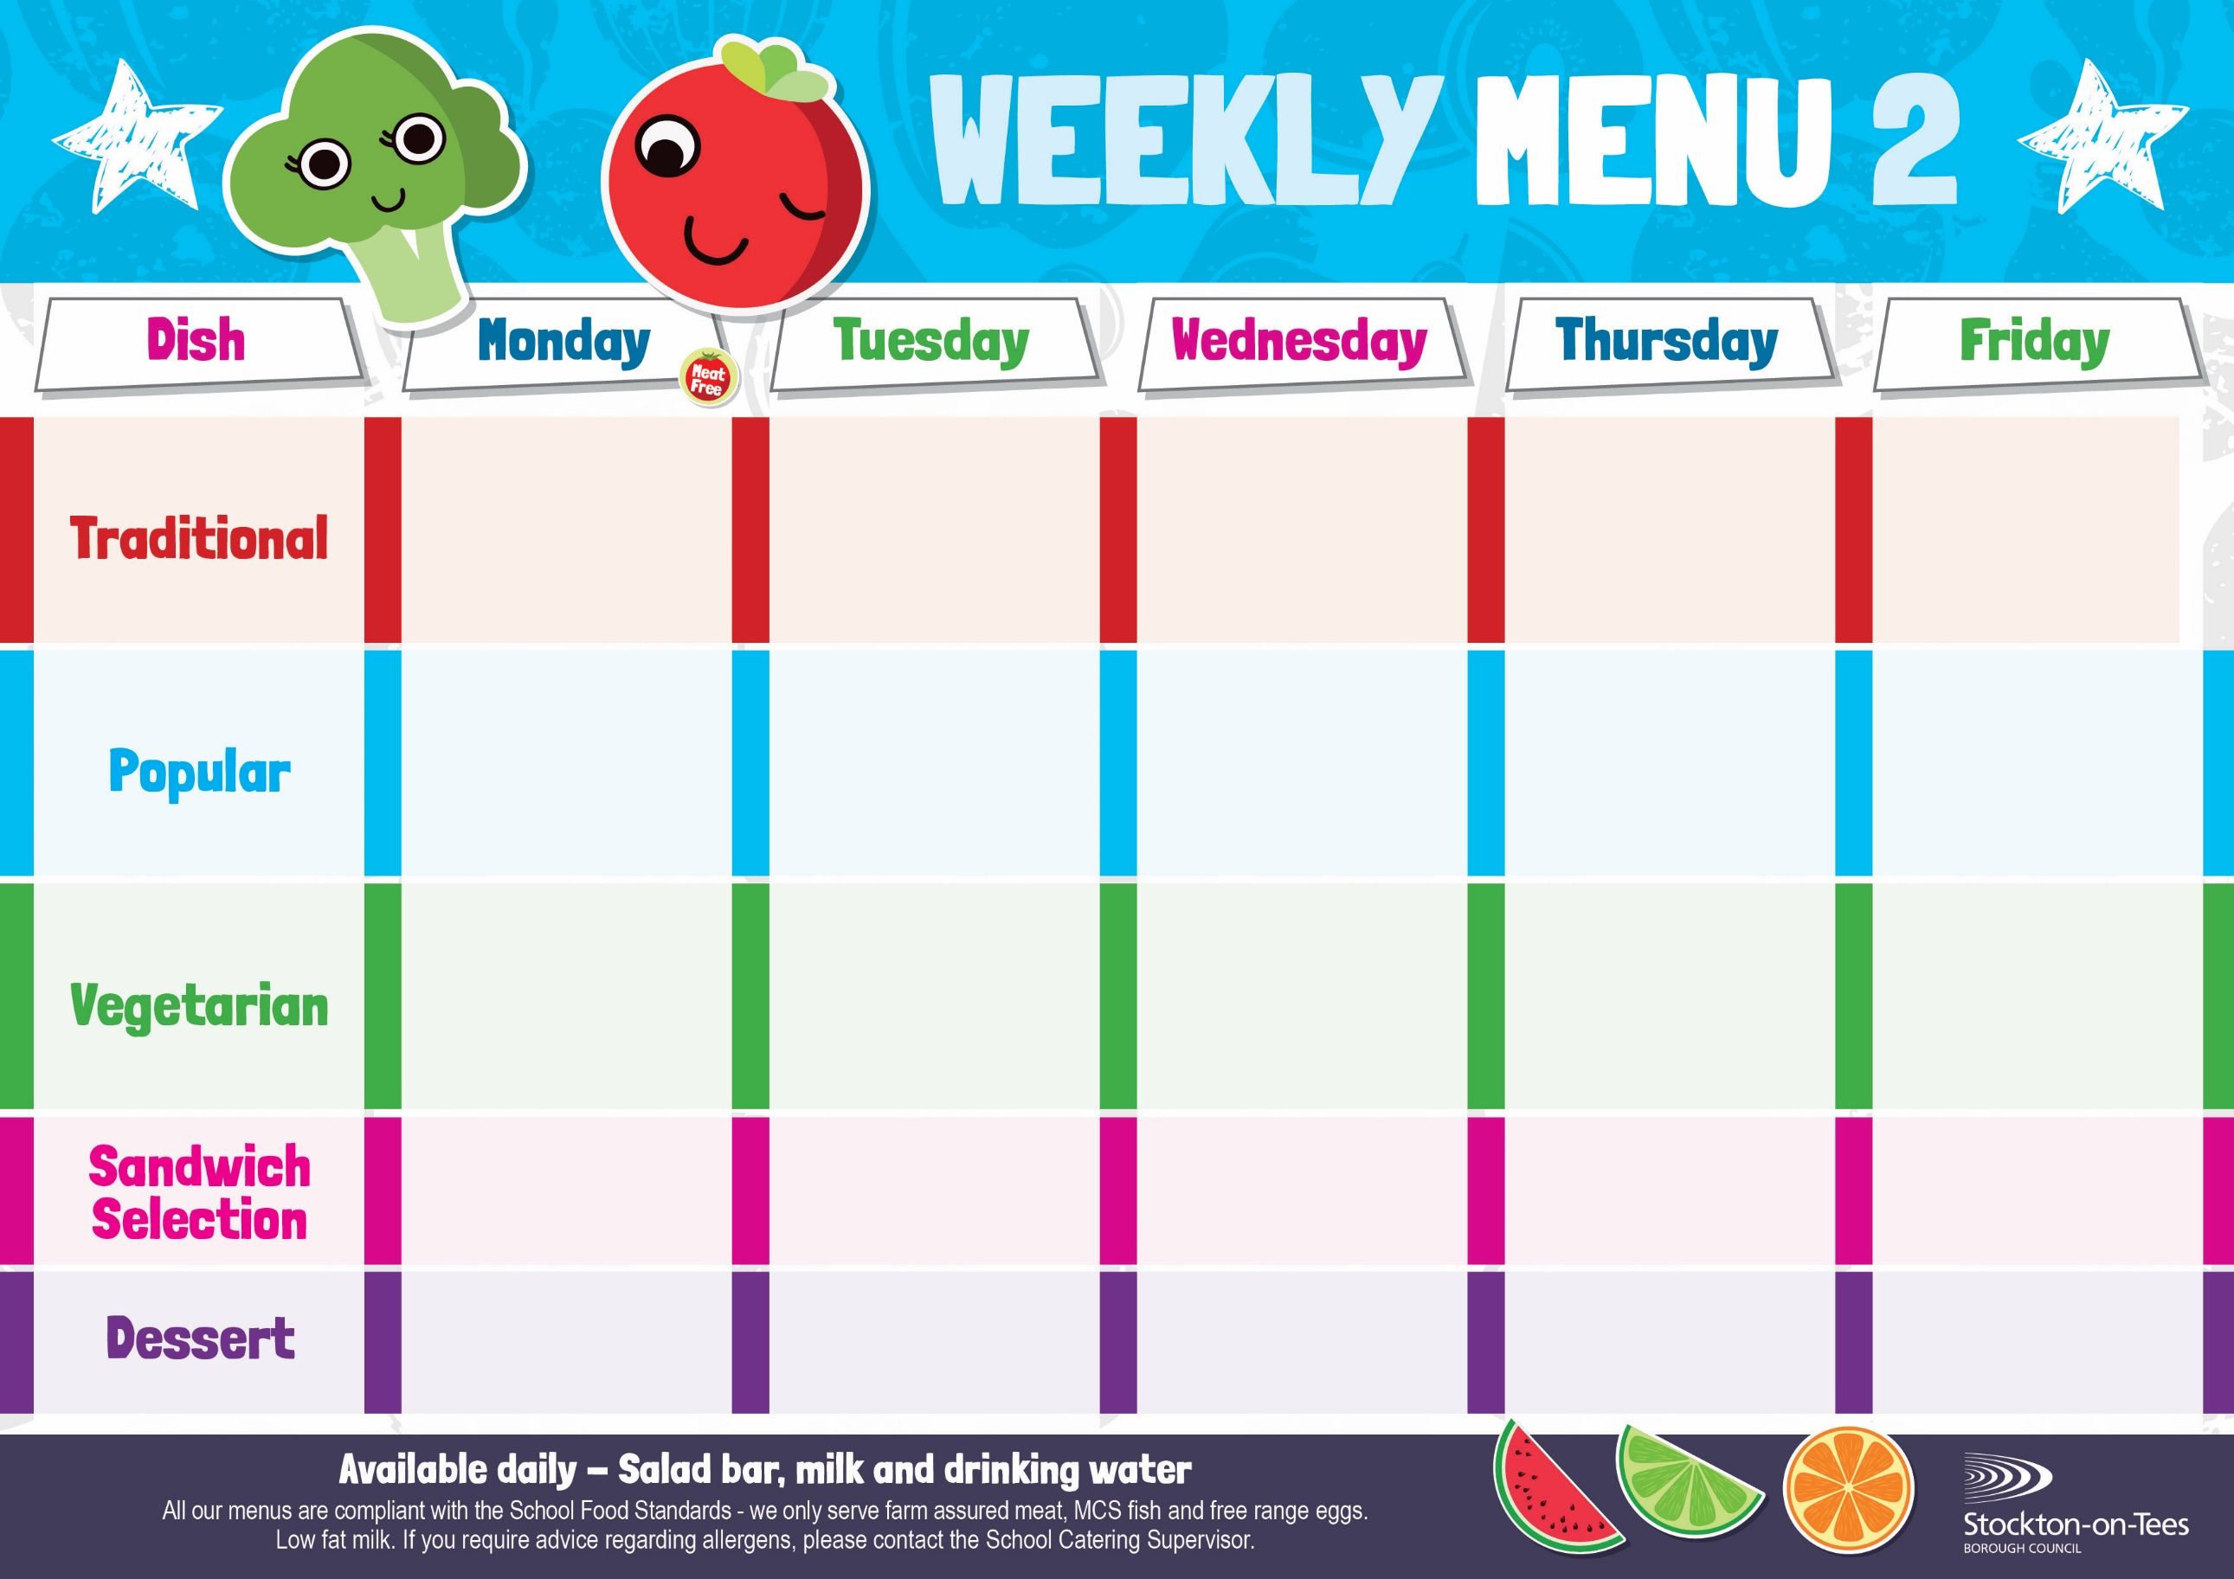
Margarita Pizza
Oven Roasted Potatoes
Baked Beans
Garden Peas

Egg Mayonnaise
Oven Roasted Potatoes
Vegan Meatballs in Tomato Sauce served with Pasta
Mixed Vegetables

Pork Meatballs
In Tomato Sauce
served with Pasta
Mixed Vegetables

Cheese
Oven Roasted Potatoes

Minced Quorn Pie
Creamed Potatoes
Swede
Broccoli
Minced Beef Pie
Creamed Potatoes
Swede
Broccoli
Weeks beginning – 7th September, 28th September, 19th October, 9th November, 30th November & 21st December, 2026

Salmon & Sweet Potato Fishcake
Roasted Potatoes
Baby Sweetcorn

Jacket Potato filled with
Cheese
Baked Beans

Cheese Omelette
Baked Jacket Potato
Broccoli
Quorn Burger
in a Bun
Roasted Potatoes
Baby Sweetcorn

Tomato Pasta Bake
Homemade Herby Bread
Garden Peas

Chicken Curry served with Rice
Mixed Vegetables
Tuna Mayonnaise

Potato Wedges
Marble Sponge &
Custard Sauce
Jelly
Homemade Biscuit &
Fresh Fruit

Creamy Rice Pudding &
Jam Sauce
Ice Cream
Homemade Biscuit &
Fresh Fruit
Bakewell Tart &
Custard Sauce
Decorated Iced Sponge
Homemade Biscuit &
Fresh Fruit
Vanilla Sponge &
Custard Sauce
Angel Delight
Homemade Biscuit &
Fresh Fruit
Fish Goujons
Oven Baked Chips
Mushy Peas
Baked Beans

Beef Burger in a Bun Roasted Potatoes
Baby Sweetcorn

Eve’s Pudding &
Custard Sauce
Chocolate Muffin
Homemade Biscuit &
Fresh Fruit
Egg Mayonnaise
Oven Baked Chips
Tuna Mayonnaise
Baked Jacket Potato
App

Jacket Potato filled with Tuna
Baked Beans
Garden Peas

