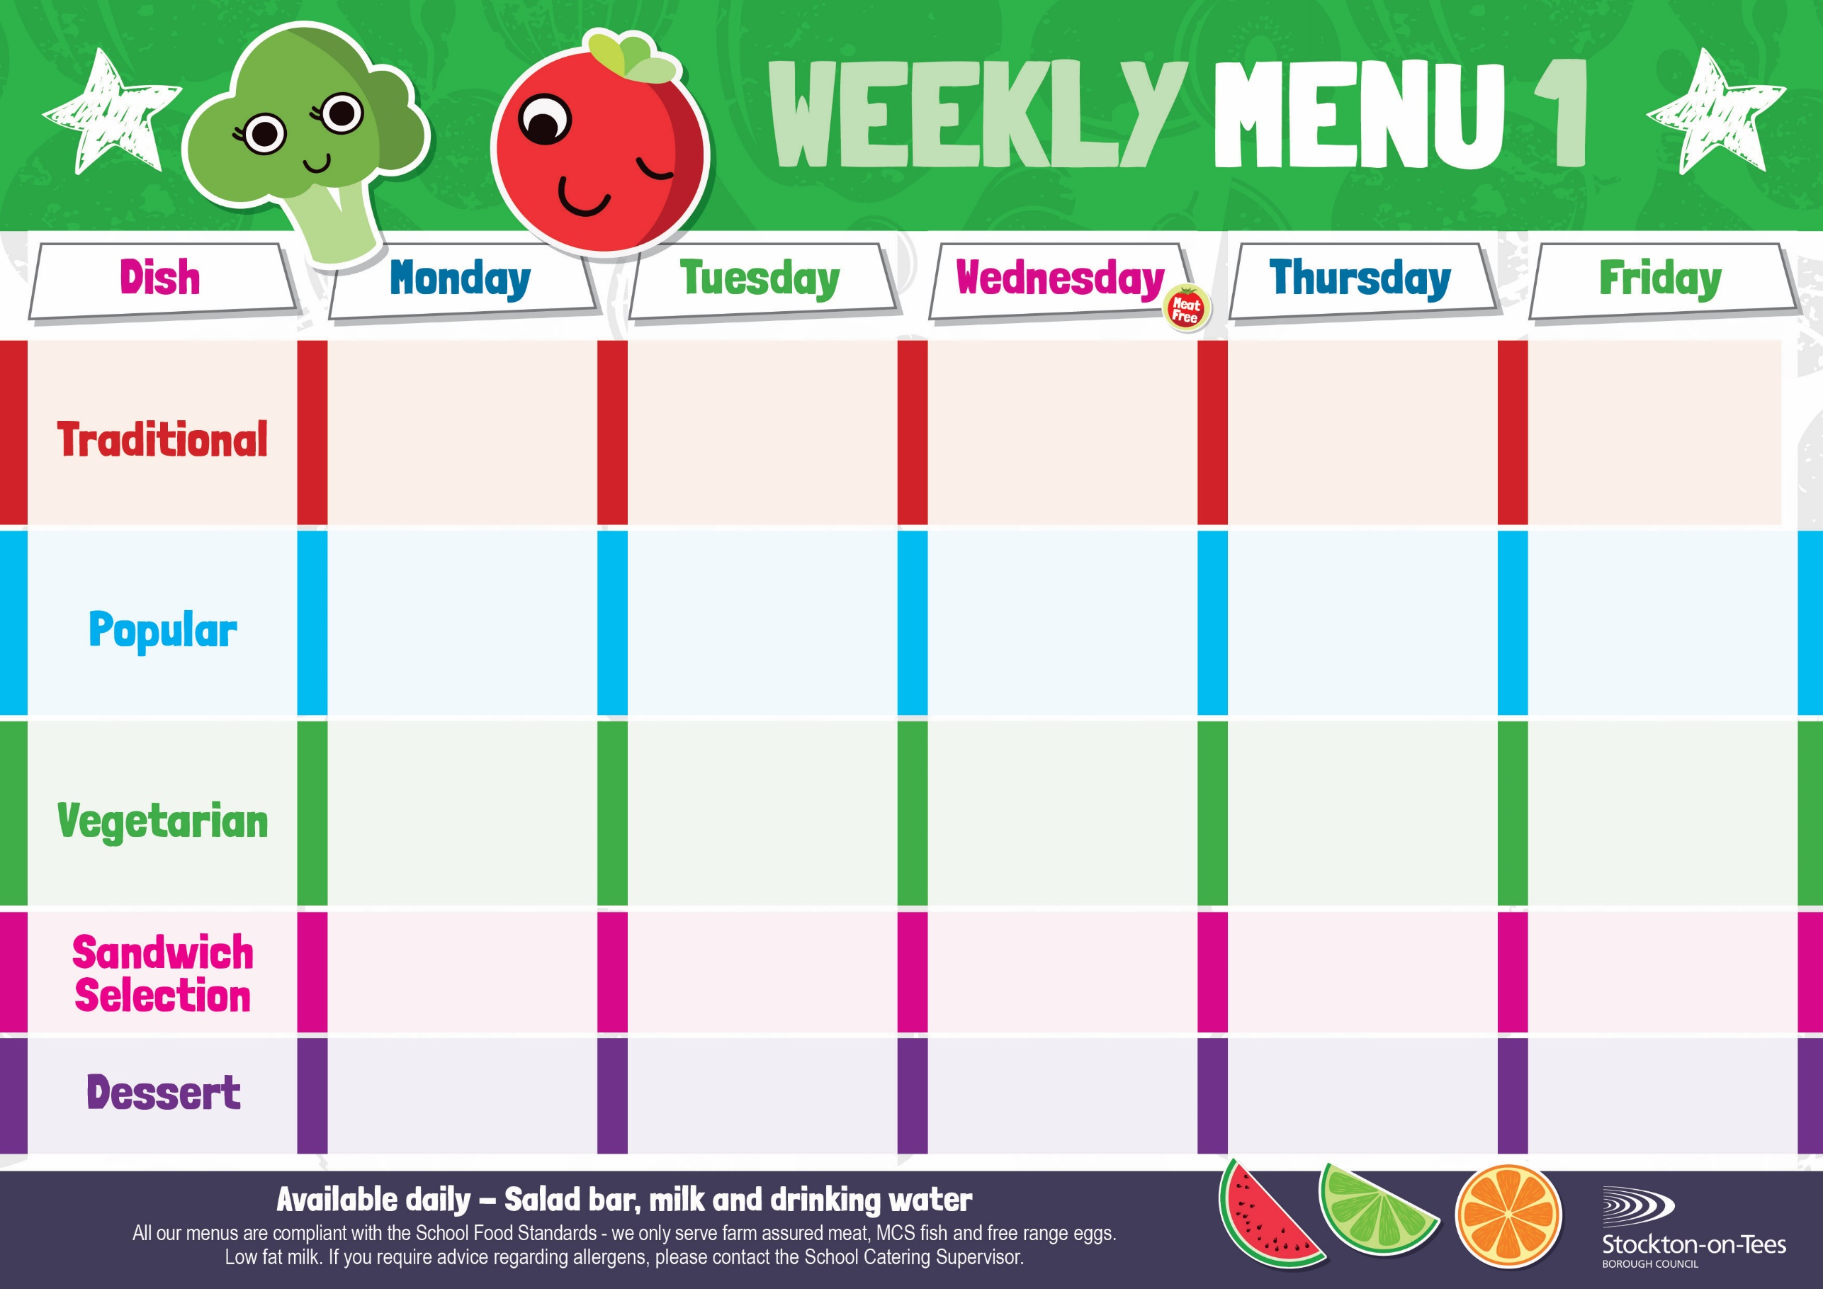
Tuna Mayonnaise

Baked Jacket Potato

Oven Baked Chips
Mushy Peas
Baked Beans

Jacket Potato
Filled with Tuna

Roast Gammon & Pineapple
Baby Boiled Potatoes
Garden Peas
Baked Tomato

Mediterranean Quorn Bolognaise
Homemade Garlic Bread
Sweetcorn

Fish Star
Baked Jacket Potato
Baked Beans
Quorn Toad in the Hole
Creamed Potatoes
Cauliflower
Mixed Vegetables

Weeks beginning - 31ST August, 21st September, 12th October, 2nd November, 23rd November & 14th December, 2026

Chicken Cobbler
Creamed Potatoes
Broccoli
Diced Carrots

Jacket Potato
Filled with
Cheese or Baked Beans

Homemade Pizza
Roasted Potatoes
Sweetcorn

Egg Mayonnaise
Roasted Potatoes

Quorn Cobbler
Creamed Potatoes
Broccoli
Diced Carrots

Harry Ramsden
Fish Fillet
Oven Baked Chips
Mushy Peas
Baked Beans

Baked Cheese Roll
Mushy Peas
Baked Beans

Tuna Mayonnaise
Potato Wedges

Roast Ham
Baked Jacket Potato
Decorated Iced Sponge & Custard Sauce
Ice Cream
Homemade Biscuit &
Fresh Fruit

Jam Roly Poly &
Custard Sauce
Cup Cake
Homemade Biscuit &
Fresh Fruit

Chocolate Sponge &
Custard Sauce
Raspberry Bun
Homemade Biscuit &
Fresh Fruit

Syrup Sponge &
Custard Sauce
Iced Bun
Homemade Biscuit &
Fresh Fruit
Apple Crumble &
Custard Sauce
Crispy Cake
Homemade Biscuit &
Fresh Fruit
Cheese
Oven Baked Chips

Mini Cheese Slice
Potato Wedges
Baked Beans
Toad in the Hole
Creamed Potatoes
Cauliflower
Mixed Vegetables

