William Cassidi Church of England Aided Primary School

Oral Health Policy

‘Life in all Fullness’
(John 10:10)



As a school, we want to provide our learners with the very best education. To let them experience life in all its fullness and living with all their heart. Our main core value of love underpins all that we do. Our school is Christ-centred and our core Christian values of love, respect, courage, service and resilience flow through every aspect of school life. It is on this bedrock that we provide an excellent education for our whole school family. We want our entire school community to be the very best that they can be and to recognise that they are precious, loved and valued.

Document Control
Policy Owner | Headteacher / Oral Health Lead
Approved By | Governing Body
Date Approved | 7th July 2026
Review Date | July 2027
Version | 1.0
Related Policies | Safeguarding, EYFS, PSHE/RSHE, First Aid, Healthy Eating
Statutory/Non-Statutory | Non-statutory
Audience | All staff and governors

1. Policy Statement
At William Cassidi C of E Aided Primary School we recognise that good oral health is an important part of children's overall health, wellbeing and readiness to learn. We are committed to promoting positive oral health through education, healthy lifestyles, partnership with families and, where appropriate, supervised toothbrushing. The school aims to help children develop lifelong healthy habits while reducing inequalities in oral health.

2. Aims
- Promote lifelong oral health habits.
- Encourage twice-daily brushing with fluoride toothpaste.
- Support healthy eating and drinking choices.
- Provide age-appropriate oral health education.
- Work in partnership with parents and health professionals.
- Reduce oral health inequalities.

3. Legislation and Guidance
This policy has regard to the following guidance:
- EYFS Statutory Framework
- School Food Standards
- Keeping Children Safe in Education
- Delivering Better Oral Health
- NHS England and Office for Health Improvement and Disparities (OHID) guidance

4. Roles and Responsibilities
Governors: Monitor implementation and review the policy.
Headteacher: Ensure the policy is implemented and staff receive appropriate information.
Oral Health Lead: Coordinate oral health activities and liaise with external agencies where appropriate.
Staff: Promote positive oral health, deliver curriculum content and follow agreed procedures.
Parents and carers: Support good oral hygiene at home and ensure children access routine dental care.
Pupils: Develop healthy habits and participate in oral health activities.

5. Promoting Oral Health
- Oral health is taught through the EYFS, Science, PSHE/RSHE and wider health education.
- The school promotes healthy snacks and water as the main drink throughout the day.
- Where applicable, supervised toothbrushing is delivered in line with local guidance and infection prevention procedures.
- Parents receive information to support healthy oral hygiene.

6. Safeguarding and Dental Emergencies
Persistent untreated dental disease may, in some circumstances, be an indicator of neglect. Any concerns will be managed in line with the school's safeguarding procedures. Dental injuries will be managed in accordance with the school's First Aid Policy and parents/carers will be informed promptly.

7. Monitoring and Review
- The Oral Health Lead will monitor implementation.
- The policy will be reviewed every two years or sooner if guidance changes.
- Operational procedures will be maintained separately and updated as required.

Appendix A

Class | Type of Rack  (Toy Rack/BrushBus)  Type of Toothbrush  (Toy/Healthy Snacks/Sports) | Storage Area  (Up high) | Tooth Brushing Area  (Where?) | Cleaning Procedure:  Of area (product used)  Of Rack:  Of Tooth brushes: | Method of brushing:  One tube of toothpaste dispensed onto?  Each child every day?  Rotational brushing – how long?
2yrs
Nursery | x | x | x | x | Plate/sheet  Each day  As directed by song
Reception | x | x | x | x | As above
Year 1
Year 2
Year 3
Year 4
Year 5
Year 6

Year groups taking part in scheme

Year | Brushing
2ys | N/A
Nursery
Rec
Y1 | x
Y2 | x
Y3 | x
Y4 | x
Y5 | x
Y6 | x

Oral Health Snack Guidance

Recommended | Occasionally | Not encouraged
Water, plain milk | Fruit juice with meals | Sugary fizzy drinks
Fresh fruit & vegetables | Dried fruit | Sweets
Cheese | Cakes | Lollipops
Plain yoghurt | Biscuits | Chewy sweets



Appendix B

 | Rack Colour
 | Toys |  | Name | Date
 |  | House
 |  | Apple
 |  | Bike
 |  | Bus
 |  | Chair
 |  | Tree
 |  | Coat
 |  | Hat
 |  | Pram
 |  | Shoe
 |  | Flower
 |  | Bed
 |  | Teddy
 |  | Bricks
 |  | Cup
 |  | Spoon
 |  | Ball
 |  | Car
 |  | Book
 |  | Pencil
Appendix C

Appendix D

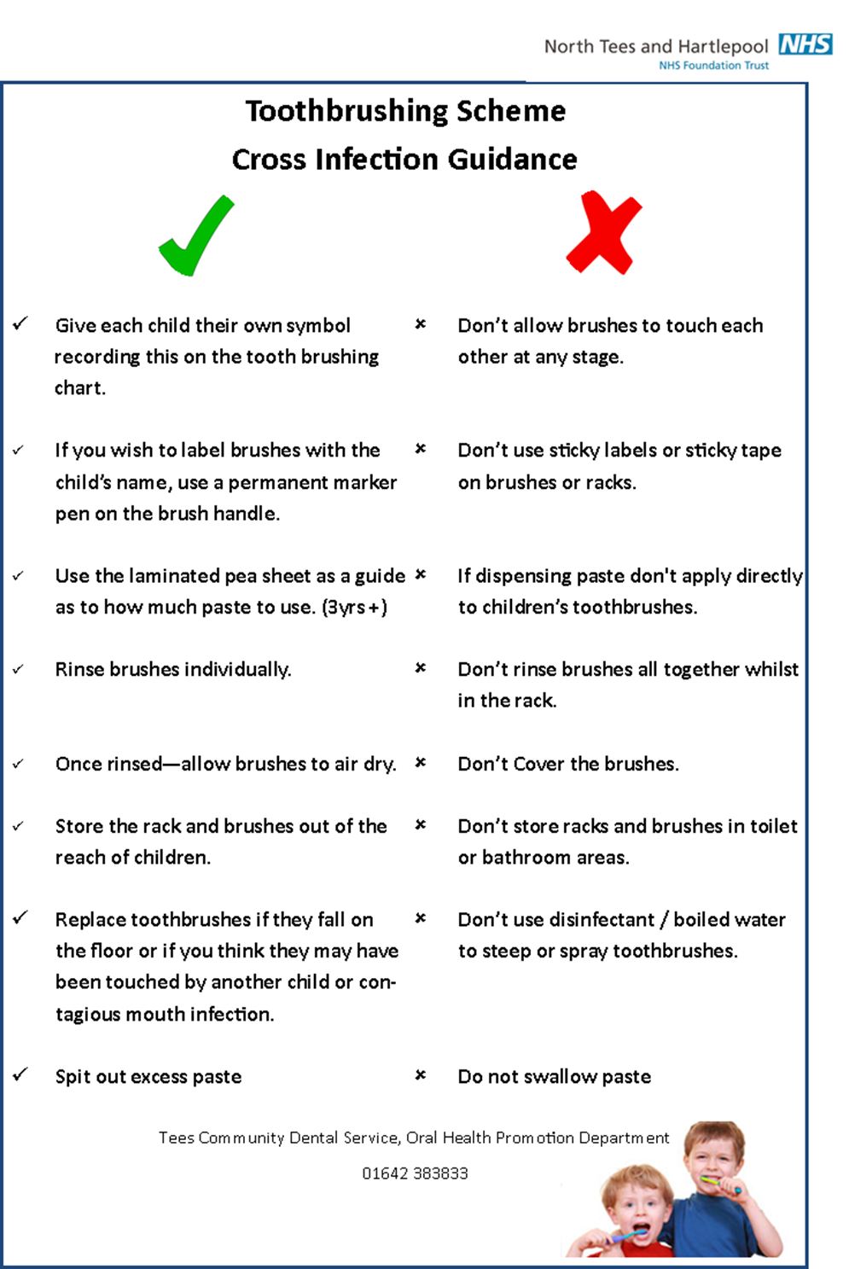
Appendix E

