William Cassidi Church of England Aided Primary School

Marking and Feedback
Policy Statement

‘Life in all Fullness’
(John 10:10)



As a school, we want to provide learners with the very best education. To let them experience life in all its fullness and living with all their heart. Our main core value of love underpins all that we do. Our school is Christ-centred and our core Christian values of love, respect, courage, service and resilience flow through every aspect of school life. It is on this bedrock that we provide an excellent education for our whole school family. We want our entire school community to be the very best that they can be and to recognise that they are precious, loved and valued.

The Importance of Feedback – Oral and Written
At William Cassidi Church of England Aided Primary School we value the importance of feedback and marking of all work completed by children. EEF research evidences the importance of feedback in relation to pupil attainment and progress. All aspects of this policy are therefore rooted in evidence informed practice and align with the school vision of ‘Life in all Fullness’. We have high aspirations of all children and high-quality feedback is one of the most effective ways of ensuring children make accelerated progress.
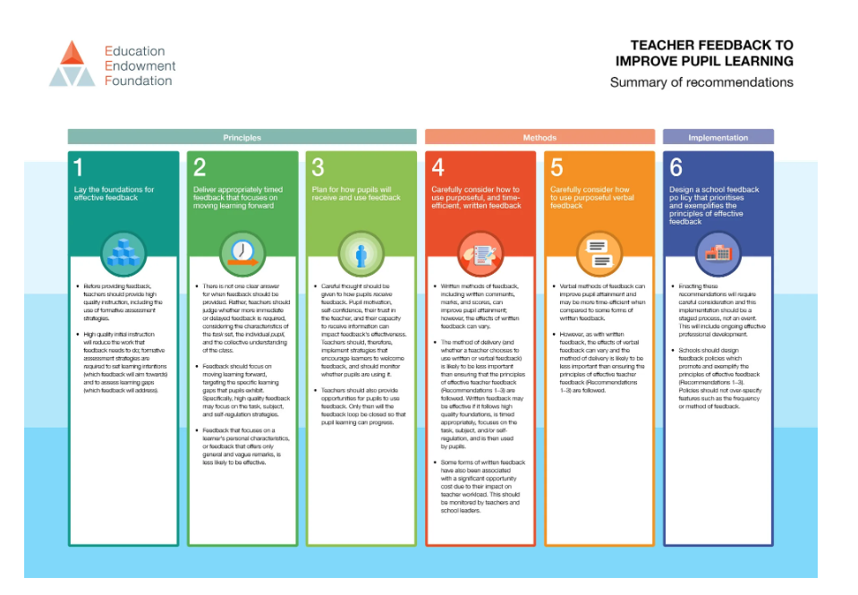

Classroom Environments – Verbal Feedback
The physical learning environment of each classroom is conducive to instant, verbal feedback. Desks are positioned with free-flow opportunities so that teachers can move freely around the space, address a misconception through verbal feedback and celebrate best practice. Instant, verbal feedback is used across every phase of the school; it has maximum impact on moving the learning forward. Each classroom has a visualizer in situ so that modelling, examples of best practice and/or unpicking misconceptions can be addressed in the moment. This effective use of assessment for learning and adaptive teaching techniques ensures that teachers are aware of pupil knowledge and understanding both in the moment. It is then additionally reviewed via written marking.

Marking of Written Work
Research shows that live marking has a significant impact on pupil progress. Wherever possible, live marking will be utilised alongside instant, verbal feedback. Live marking lends itself better to specific subjects e.g. Maths whereby answers can be skimmed/scanned and therefore checked at a quicker pace. Whenever practical, the work will be marked with the child to allow for reflection, discussion, observation and engagement with learning.

We mark all written work in line with the child’s age and stage of development. Written marking is always linked to the learning objective. Work is always marked by the teacher who sets and delivers the lesson. We aim to mark work the same day it is completed so that children have the necessary feedback before moving on to the next sequence of learning. All written work is marked in green pen.

In order to provide a consistent whole school approach and reduce staff workload, written marking follows a specific marking code criteria. All children across every phase therefore understand the marking symbols as they are used from Reception class onwards.

Early Years Marking Annotations

What Does My Mark Mean?

a | Learning objective is achieved
pa | Learning objective is partly achieved
√ | Work is correct
d | Discussion has taken place
☺ | Great Work
→ | A ‘next step’ for you to complete
sp | Spelling error
 | An error has been made
ws | Worked with support

Key Stage One Marking Annotations

What Does My Mark Mean?

a | Learning objective is achieved
pa | Learning objective is partly achieved
√ | Work is correct
d | Discussion has taken place
☺ | Great Work
→ | A ‘next step’ for you to complete
sp | Spelling error
 | An error has been made
ws | Worked with support

Key Stage Two Marking Annotations
What Does My Mark Mean?

a | Learning objective is achieved
pa | Learning objective is partly achieved
√ | Work is correct
d | Discussion has taken place
☺ | Great Work
→ | A ‘next step’ for you to complete
sp | Spelling error
 | An error has been made
ws | Worked with support

Pupil Response to Written Marking
From Y2 onwards (more able Y2 pupils), children will be issued with purple pens to edit, improve, correct or extend any aspects of their work as a result written marking. Not all responses to feedback will be identified in books e.g. instant verbal feedback during a lesson will be less discrete to identify as the child will be using their original writing instrument; however, misconceptions that may have occurred within a lesson (and not been fully identified at the time) can be addressed via written marking. If corrections or extensions of learning have been identified by the teacher, time must be built in for pupils to respond (via purple pens) in the proceeding lesson.

As teachers mark written work they will review the work as a sequence of learning (often flicking back and forth across work samples) to ensure children are not repeating mistakes that have been identified previously and are advancing in terms of improvements with presentation, volume of work and increasing challenge of tasks.

Peer and Self-Assessment
The ability to conduct self-assessment and peer-assessment will be developed as children progress through the school and incorporated into the marking process. These methods of assessment must be taught to the pupils so that they understand how to provide constructive feedback and that their feedback and marking has impact. Where appropriate, these methods of assessment should be utilised e.g. self-marking of spelling tests, arithmetic tests, etc… with correct answers displayed on the board is an effective way to use self-assessment. Children can then identify what they have done well and the next steps for learning. Peer assessing longer pieces of writing is also an effective use of this assessment tool as the children read aloud the work of their partner to ensure writing is cohesive and has an awareness of the reader. These methods of assessment can be implemented by teachers wherever they feel appropriate and in relation to the subject and phase of school.

Observational Assessment
The use of observational assessment is embedded in the Foundation Stage and is becoming increasingly deployed throughout Key Stages One and Two. It provides vital information about the development and progress individuals are making across the areas of learning. Children may be observed exploring concepts and engaging in practical activities, which provide concrete evidence of attainment and stages of development. Observational assessment is undertaken through focused, planned group or individual activities, enhanced provision observations and in practical areas of study, activities or visits. Photographic and video evidence (with parental permission) is used to support observational assessment, which can be undertaken by all adults working with our children or by the children themselves to record their experiences and work.

Policy approved by the governing body: 7th July 2026
Date for review: July 2027

