




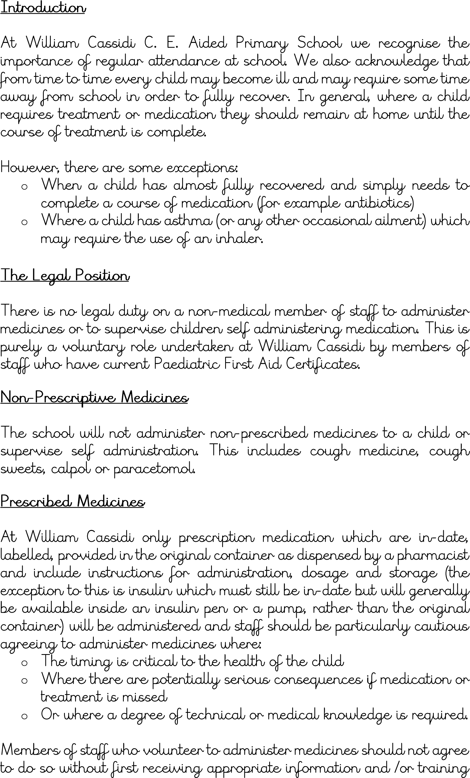
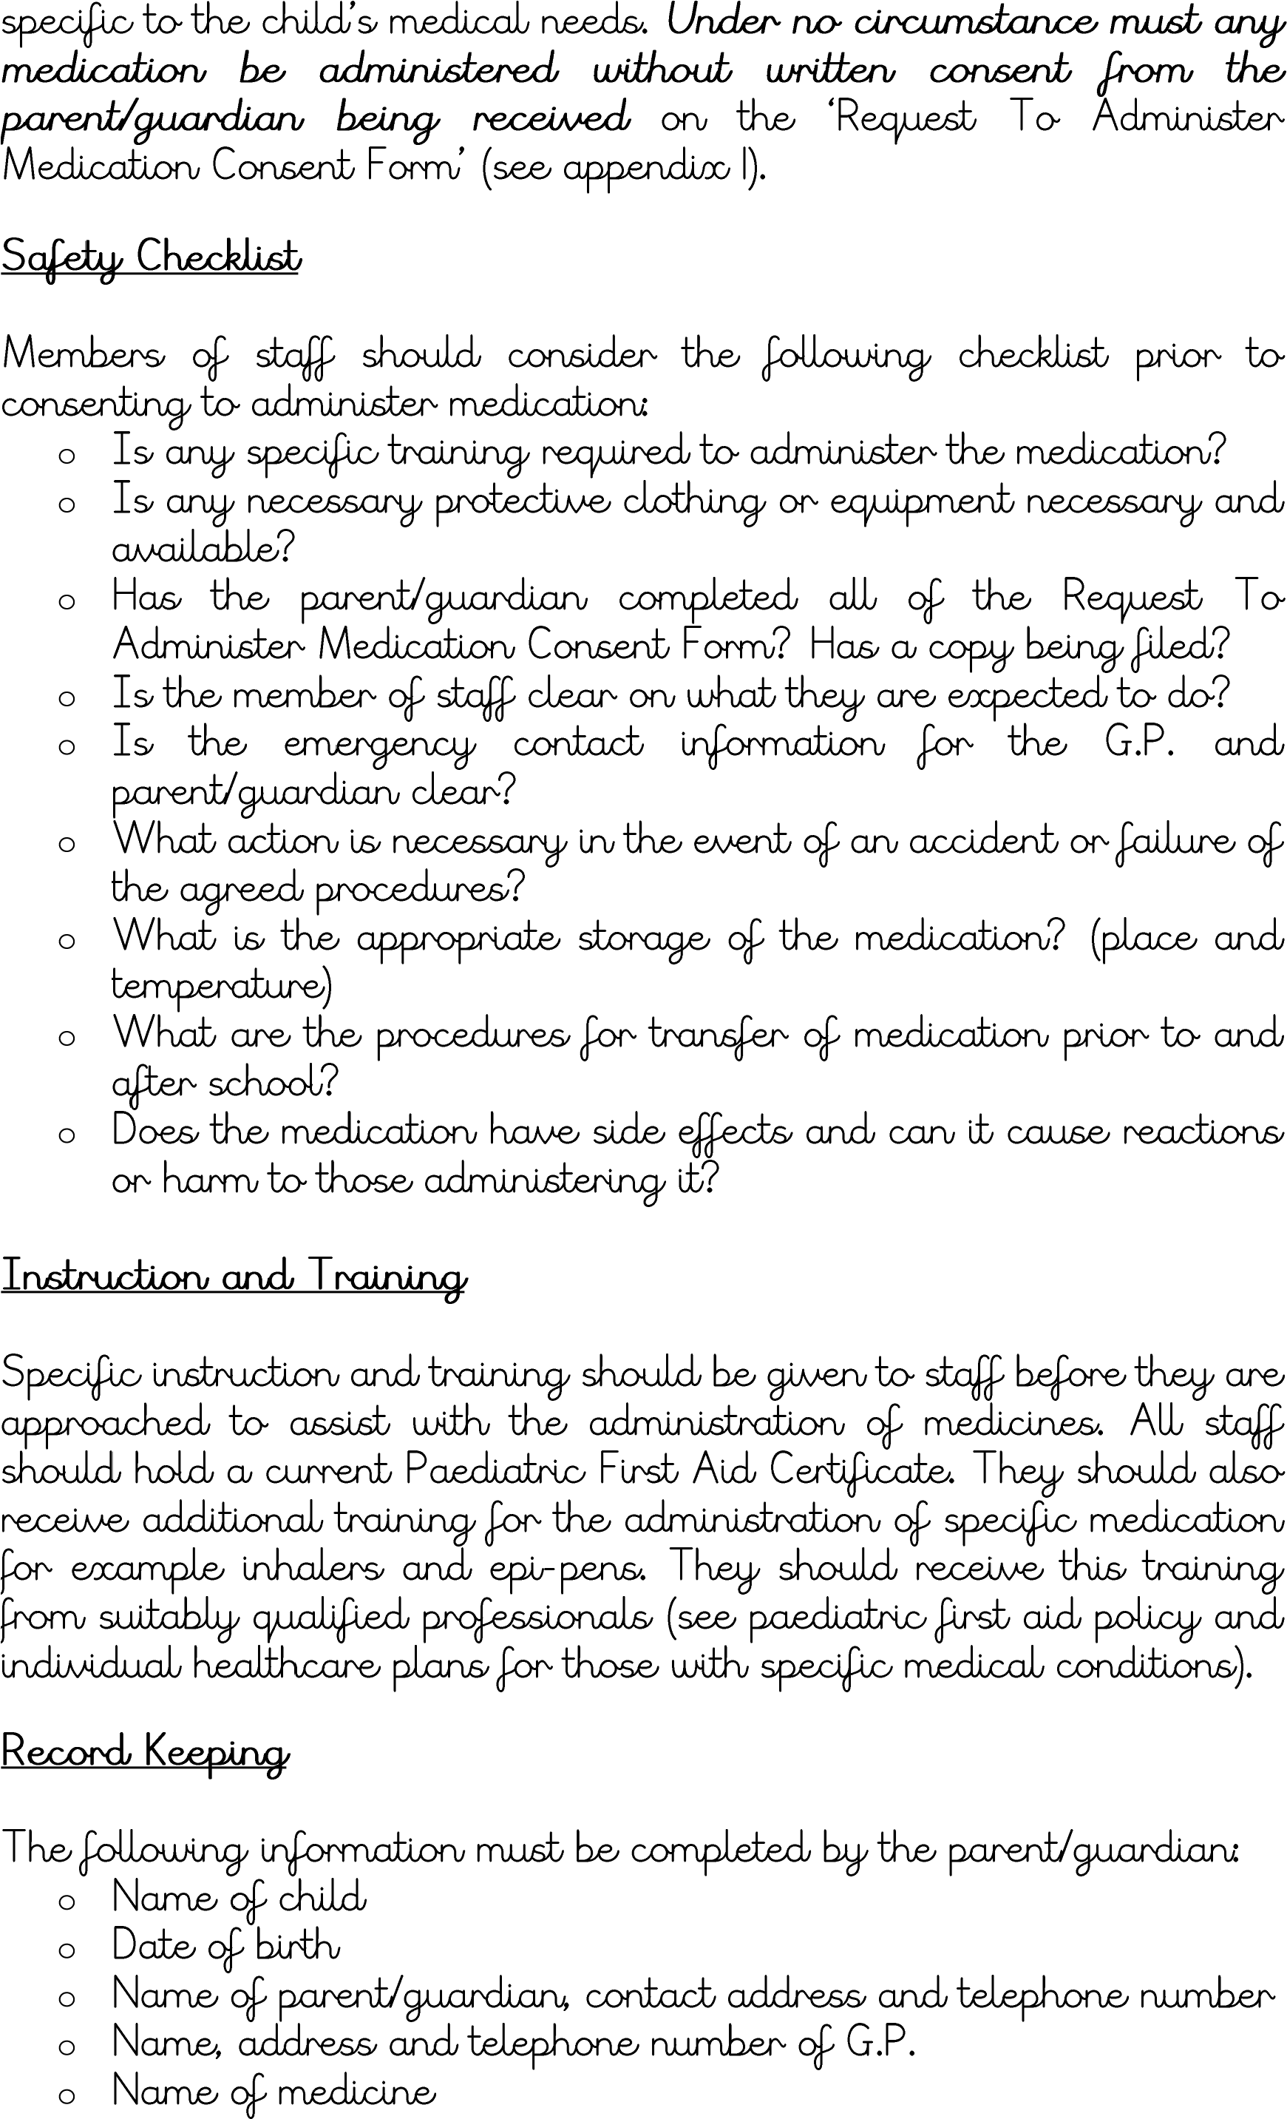
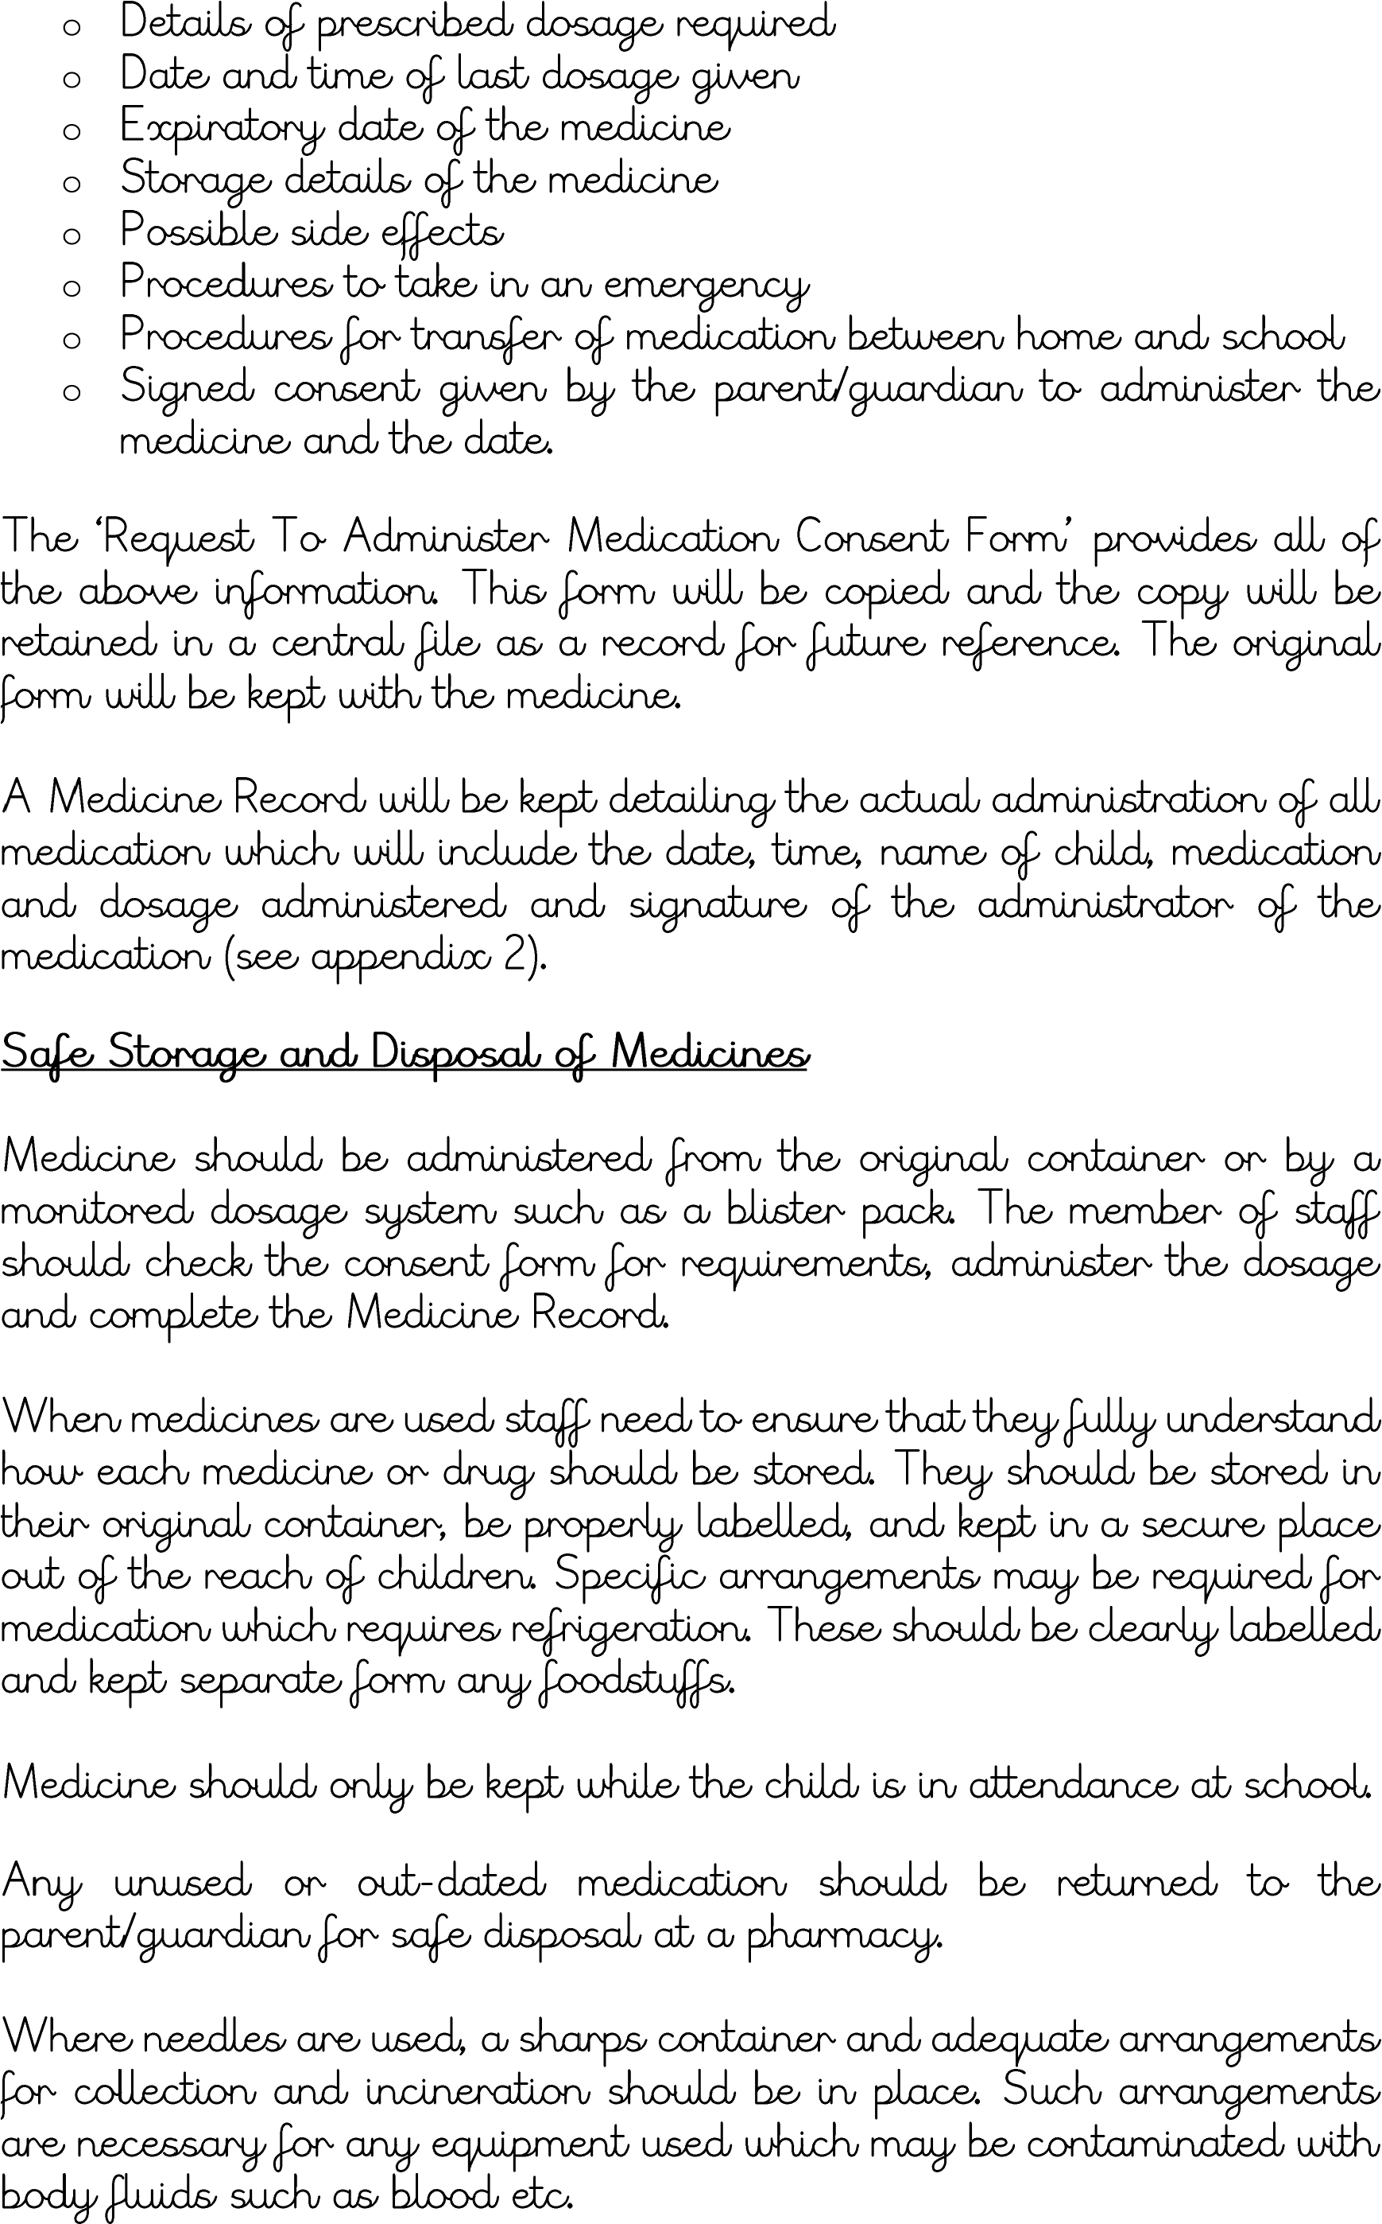
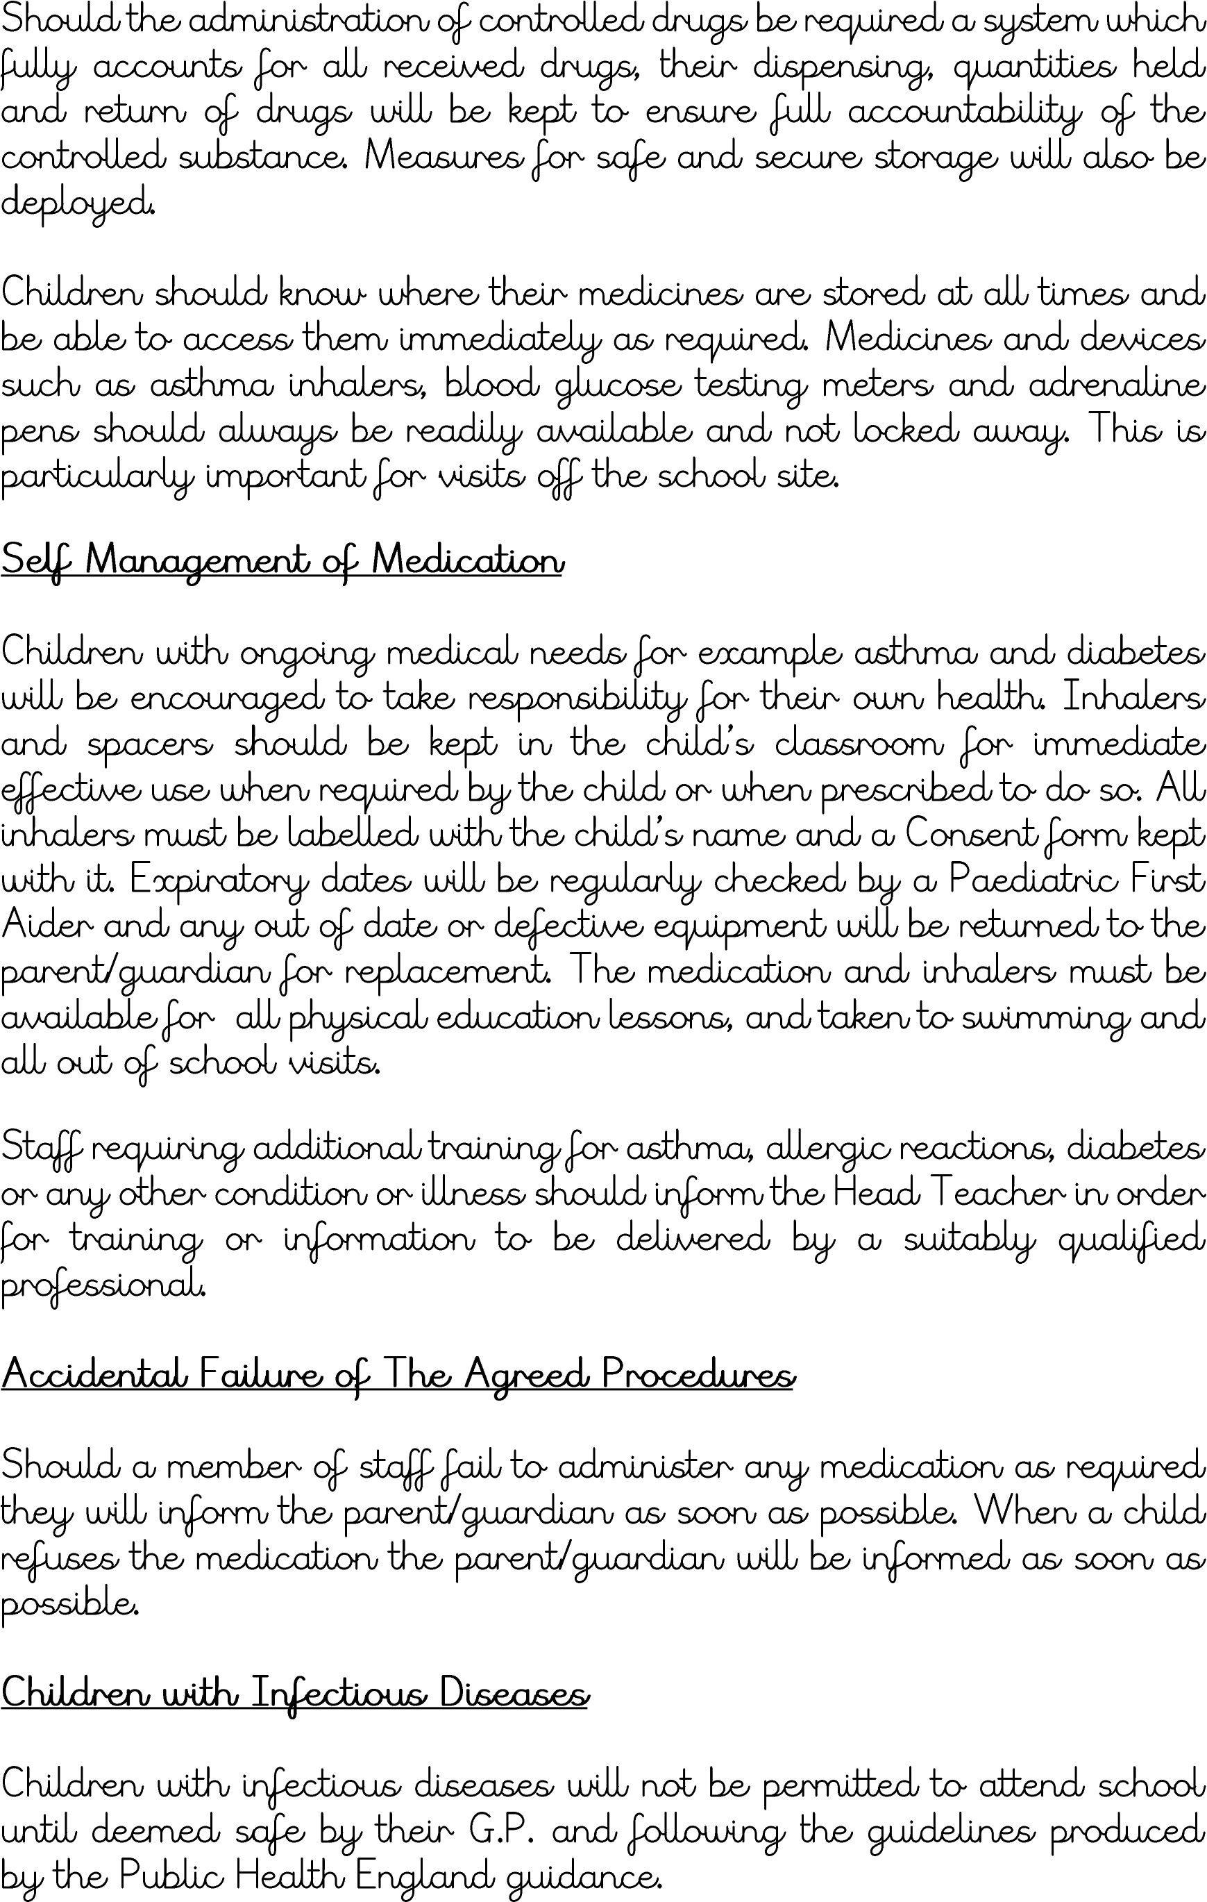



William Cassidi C. E. Aided Primary School Agreement To Administer Medicine Form
William Cassidi School will not give your child medicine unless you complete and sign this form. The school has a policy that paediatric first aid trained staff can administer medicine.
Date for review to be initiated by
Name of school/setting
Name of child
Date of birth
Group/class/form
Medical condition or illness

Medicine
Name/type of medicine
(as described on the container)
Expiry date
Dosage and method
Timing
Special precautions/other instructions
Are there any side effects that the school/setting needs to know about? Self-administration – y/n
Procedures to take in an emergency
NB: Medicines must be in the original container as dispensed by the pharmacy

Contact Details
[agreed member of staff]
Name
Daytime telephone no.
Relationship to child
Address
I understand that I must deliver the medicine personally to

The above information is, to the best of my knowledge, accurate at the time of writing and I
give consent to school staff administering medicine in accordance with the school’s policy. I will inform the school immediately, in writing, if there is any change in dosage or frequency of the medication or if the medicine is stopped.

Signature(s) ______________________ Date
Record of Medicine Administered to an
Individual Child
Name of school/setting
Name of child
Date medicine provided by parent
Group/class/form
Quantity received
Name and strength of medicine
Expiry date
Quantity returned
Dose and frequency of medicine

Staff signature _________________________

Signature of parent ________________________

Date
Time given
Dose given
Name of member of
staff Staff initials

Date
Time given
Dose given
Name of member of
staff
Staff initials

C: Record of medicine administered to an individual child (Continued)

Date
Time given
Dose given
Name of member of
staff Staff initials

Date
Time given
Dose given
Name of member of
staff
Staff initials

Date
Time given
Dose given
Name of member of
staff
Staff initials

Date
Time given
Dose given
Name of member of staff
Staff initials

Staff Training Record – Administration of Medicines

William Cassidi C. E. Aided Primary School
Name of school
Name
Type of training received
Date of training completed
Training provided by
Profession and title

I confirm that [name of member of staff] has received the training detailed above and is competent to carry out any necessary treatment. I recommend that the training is updated [name of member of staff].

Trainer’s signature ____________________________

Date ________________

I confirm that I have received the training detailed above.

Staff signature ____________________________

Date ________________

Suggested review date ______________

