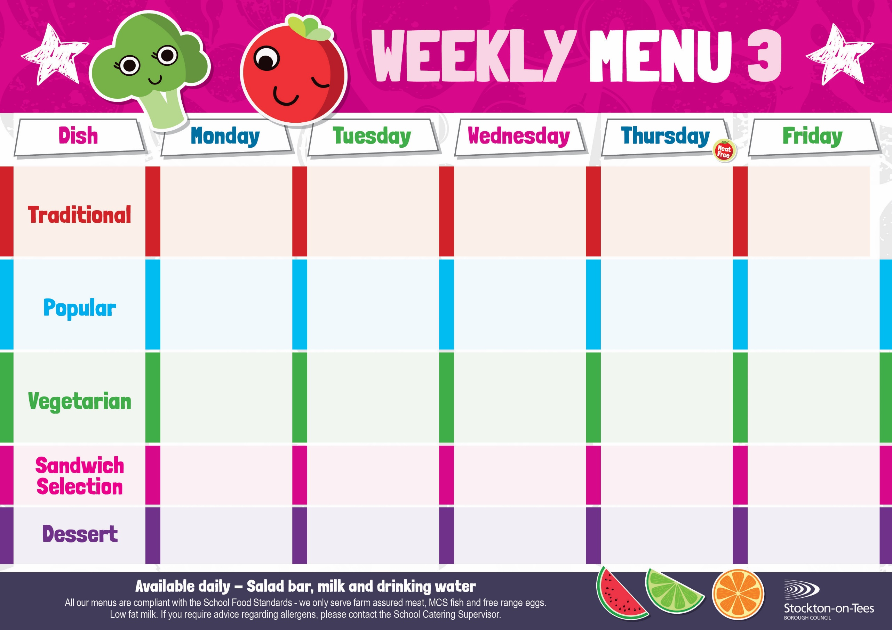
Sausage Roll
Roast Potatoes Garden Peas

Oven Baked Chips
Garden Peas &
Baked Beans

Quorn Sausage in a Bun
Roasted Potatoes
Sweetcorn
Vegan Dippers
Potato Wedges
Garden Peas

Mini Cheese Slice
Lasagne
Homemade Garlic Bread
Sweetcorn
Baked Jacket Potato with
Cheese
Baked Beans
Vegan Quorn Meatballs in Tomato Sauce
Served with Pasta
Garden Peas

Salmon & Sweet Potato Fishcake
Baked Jacket Potato
Garden Peas

Homemade Pizza

Roast Ham
Baked Jacket Potatoes
Pork & Carrot Meatballs served with Pasta in a Tomato Sauce
Garden Peas

Hot Dog in a Bun
Roasted Potatoes
Sweetcorn

Tuna Mayonnaise
Potato Wedges
Harry Ramsden
Fish Fillet
Oven Baked Chips
Garden Peas &
Baked Beans
Weeks beginning - 4th May, 1st June, 22nd June, 13th July, 2026

Decorated Iced Sponge &
Custard Sauce
Ice Cream
Homemade Biscuit &
Fresh Fruit

Jam Roly Poly &
Custard Sauce
Crispy Cake
Homemade Biscuit &
Yoghurt

Chocolate Sponge & Custard Sauce
Jelly
Homemade Biscuit &
Fresh Fruit

Creamy Rice Pudding
with Jam Sauce
Cup Cake
Homemade Biscuit &
Yoghurt
Choc Chip Sponge &
Custard Sauce
Iced Bun
Homemade Biscuit &
Fresh Fruit
Cheese
Roasted Potatoes
Tuna Mayonnaise
Oven Baked Chips
Egg Mayonnaise

Potato Wedges
Breaded Chicken Breast Fillet
Potato Wedges
Garden Peas

Potato Wedges
Baked Beans

