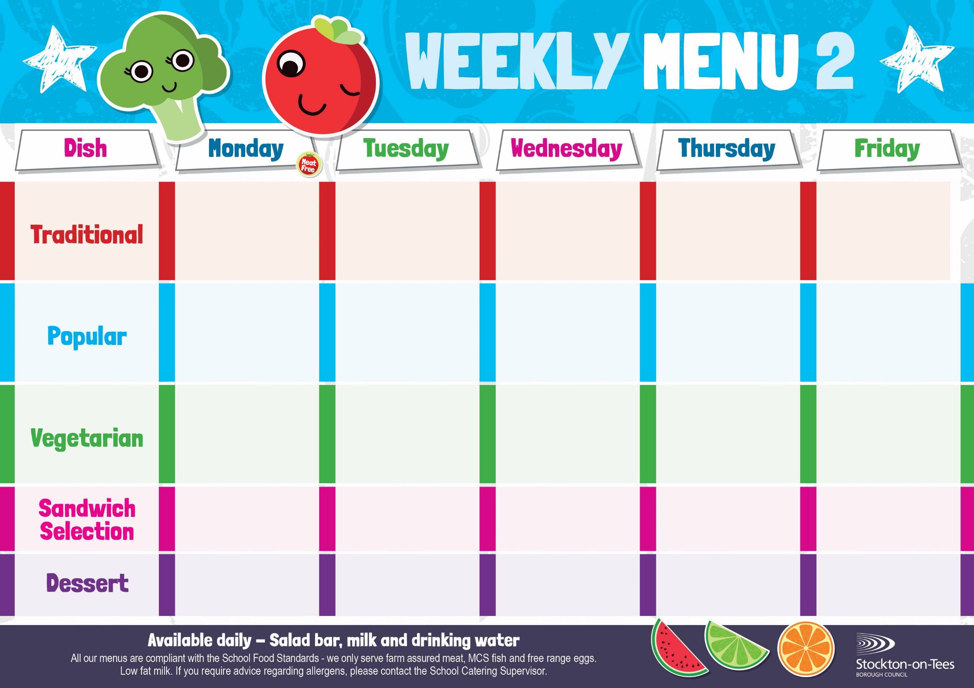
Chicken Casserole & Dumplings
Creamed Potatoes
Cauliflower
Carrots
Homemade Cheese Quiche
Roasted Potatoes
Baked Beans
Sweetcorn

Egg Mayonnaise
Baked Potato Wedges

Corned Beef Pie
Creamed Potatoes
Mixed Vegetables

Margarita Pizza
with Tuna

Quorn Bolognaise
Homemade Garlic Bread
Mixed Vegetables

Jacket Potato filled with
Cheese
Baked Beans

Diced Quorn & Dumplings
Creamed Potatoes
Cauliflower
Carrots
Fish Star
Baked Jacket Potato
Baked Beans
Quorn Burger
in a Bun
Roasted Potatoes
Baked Beans
Sweetcorn

Macaroni Cheese
Homemade Garlic Bread
Garden Peas

Weeks beginning - 27th April, 18th May, 15th June, 6th July, 2026

Spaghetti Bolognaise
Homemade Garlic Bread
Mixed Vegetables

Roast Ham

Baked Jacket Potato

Ginger Sponge &
Custard Sauce
Crispy Cake
Homemade Biscuit &
Fresh Fruit

Creamy Rice Pudding &
Jam Sauce
Ice Cream
Homemade Biscuit &
Fresh Fruit
Cornflake Tart &
Custard Sauce
Chocolate Muffin
Homemade Biscuit &
Fresh Fruit
Jam Sponge &
Custard Sauce
Jelly
Homemade Biscuit &
Fresh Fruit
Fish Goujons
Oven Baked Chips
Garden Peas
Baked Beans

Beef Burger in a Bun Roasted Potatoes
Baked Beans
Sweetcorn

Chocolate Crunch &
Custard Sauce
Decorated Iced Sponge
Homemade Biscuit &
Fresh Fruit
Cheese
Oven Baked Chips
Egg Mayonnaise
Potato Wedges

Tuna Mayonnaise
Baked Jacket Potato
App
Jacket Potato filled
Baked Potato Wedges
Garden Peas

