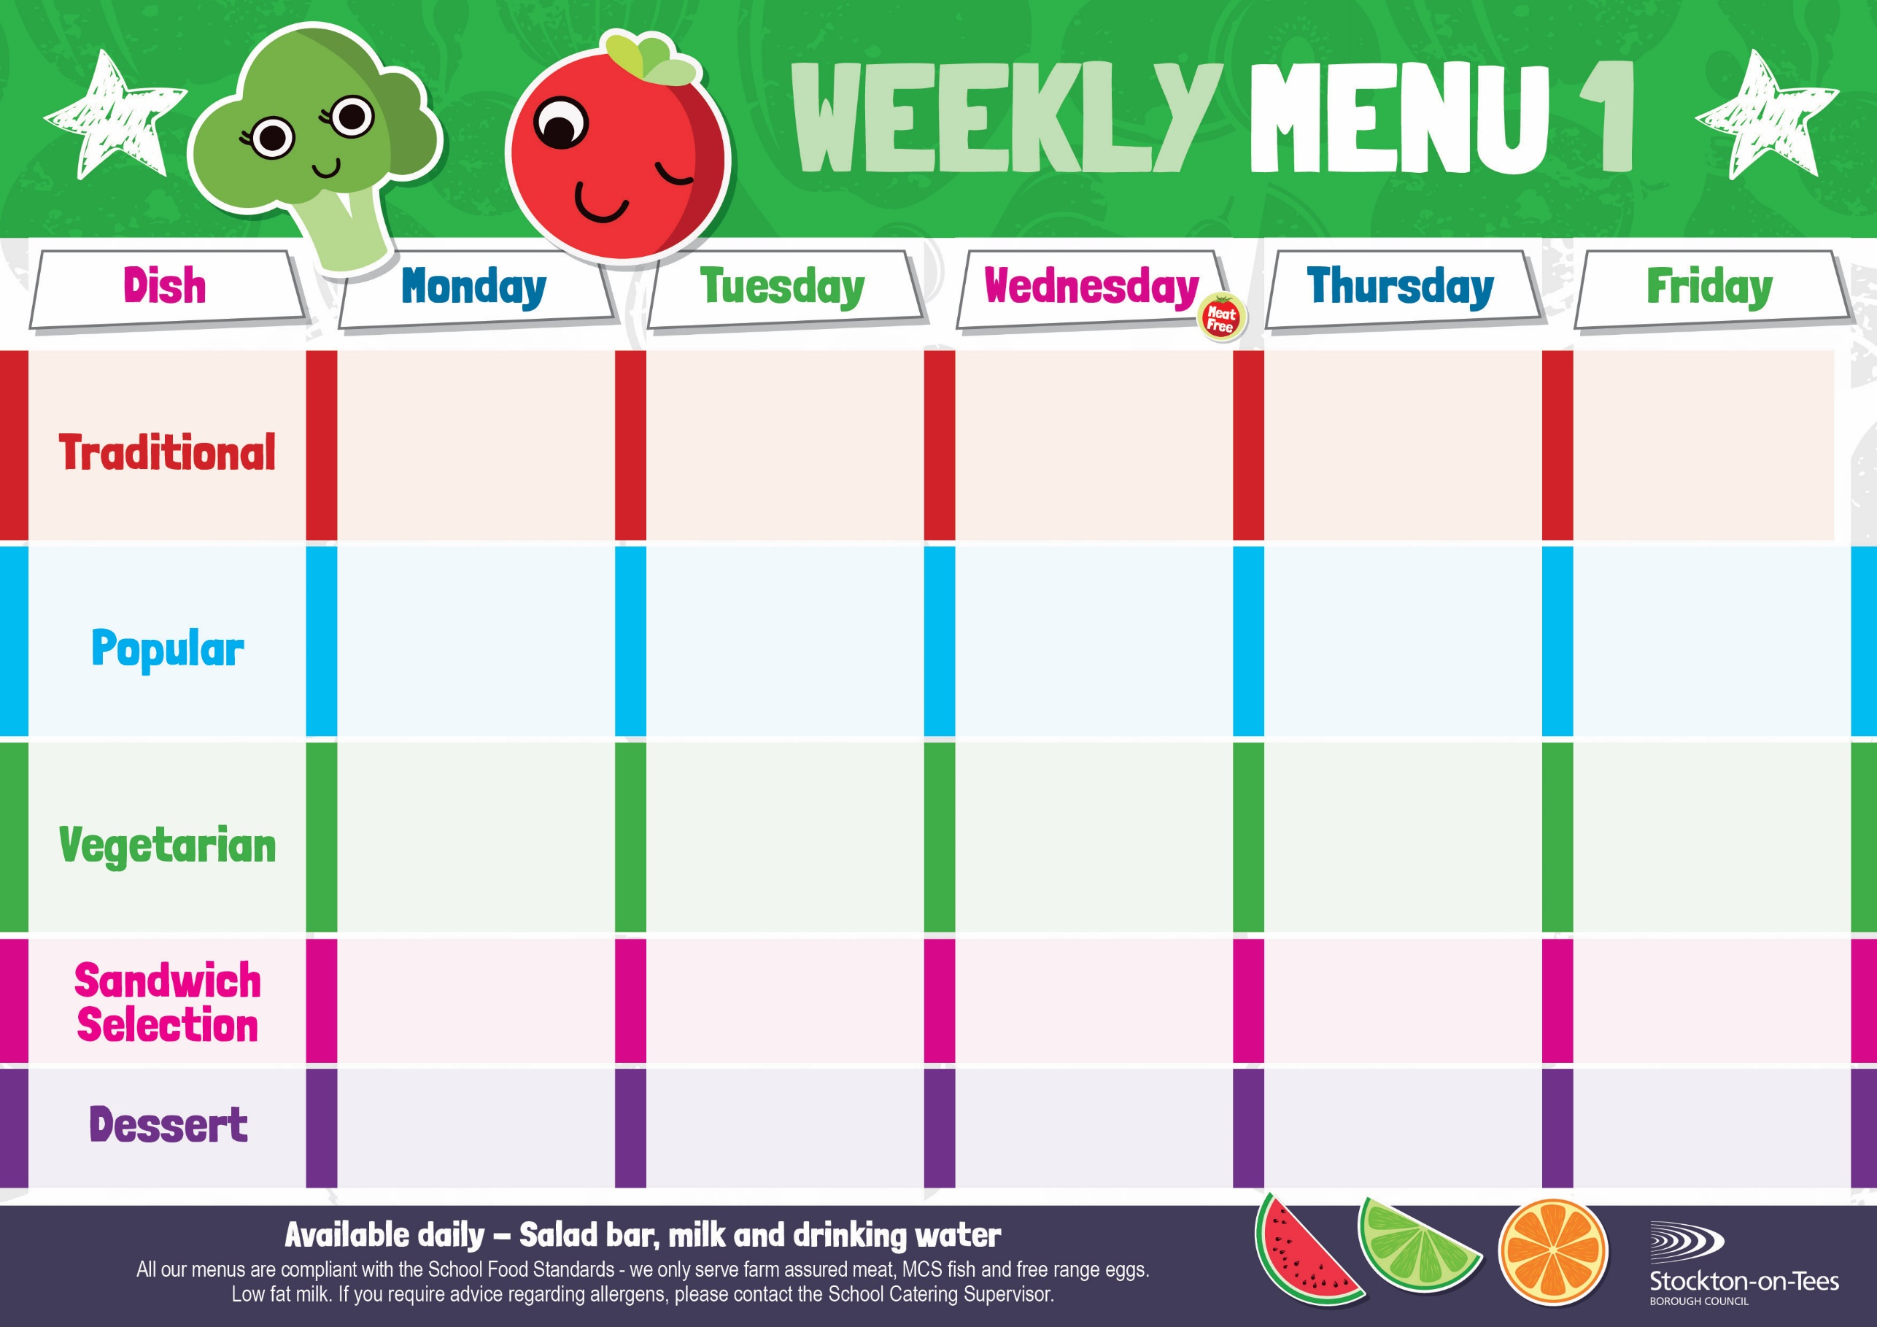
Chicken & Vegetable Pie
Creamed Potatoes
Cauliflower
Diced Carrots

Baked Cheese Roll
Baked Jacket Potato
Baked Beans

Homemade Pizza
Oven Baked Chips
Mushy Peas
Baked Beans

Egg Mayonnaise
Roasted Potatoes

Tomato Pasta Bake
Homemade Herby Bread
Sweetcorn

Jacket Potato with
Tuna

Jacket Potato with
Cheese or Baked Beans

Minced Beef & Yorkshire Pudding
Creamed Potatoes
Broccoli
Mixed Vegetables

Quorn Sausages
Oven Baked Chips
Mushy Peas
Baked Beans

Harry Ramsden
Fish Fillet
Oven Baked Chips
Mushy Peas
Baked Beans
Cheese Omelette
Roasted Potatoes
Garden Peas
Baked Beans

Baked Sausages
Roasted Potatoes
Sweetcorn

Egg Mayonnaise
Roasted Potatoes

Ham
Baked Jacket Potato
Tuna Mayonnaise

Baked Jacket Potato

Weeks beginning - 20th April, 11th May, 8th June, 29th June, 20th July, 2026

Decorated Iced Sponge & Custard Sauce
Ice Cream
Homemade Biscuit &
Fresh Fruit

Syrup Roly Poly &
Custard Sauce
Iced Bun
Homemade Biscuit &
Fresh Fruit

Marble Sponge &
Custard Sauce
Fruity Cookie
Homemade Biscuit &
Fresh Fruit

Apple Crumble &
Custard Sauce
Jelly
Homemade Biscuit &
Fresh Fruit
Vanilla Sponge &
Custard Sauce
Flapjack
Homemade Biscuit &
Fresh Fruit
Cheese
Oven Baked Chips

Fish Fingers
Roasted Potatoes
Garden Peas
Baked Beans

