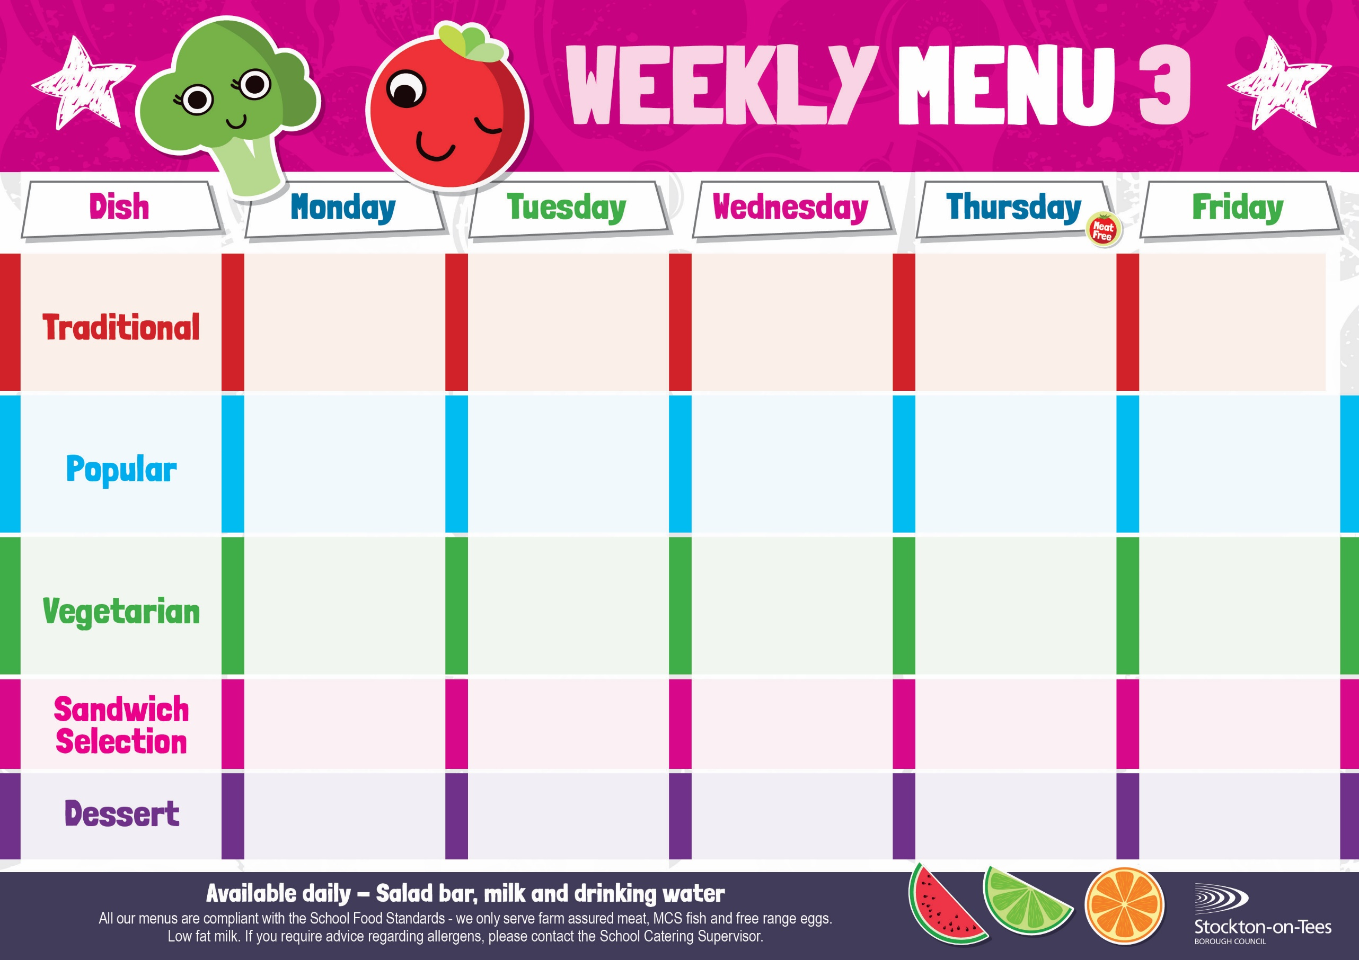

Baked Jacket Potato with Cheese or Baked Beans

Homemade Pizza
Potato Wedges
Baked Beans

Roast Ham
Baked Jacket Potatoes
Quorn Lasagne
Homemade Garlic Bread
Garden Peas
Lasagne
Homemade Garlic Bread
Garden Peas
Hot Dog in a Roll
Roasted Potatoes
Baked Beans
Mini Cheese Slice
Potato Wedges
Sweetcorn
Corned Beef Pie
Roasted Potatoes
Cabbage & Carrots
Fish Star
Baked Jacket Potato
Garden Peas

Cheese
Potato Wedges
Quorn Sausage in a Bun
Roasted Potatoes
Baked Beans

Vegan Dippers
Potato Wedges
Sweetcorn

Harry Ramsden
Fish Fillet
Oven Baked Chips
Garden Peas &
Baked Beans
Weeks beginning - 19th January, 9th February, 9th March & 30th March, 2026

Decorated Iced Sponge &
Custard Sauce
Ice Cream
Homemade Biscuit &
Fresh Fruit

Jam Roly Poly &
Custard Sauce
Crispy Cake
Homemade Biscuit &
Yoghurt

Marble Sponge & Custard Sauce
Jelly
Homemade Biscuit &
Fresh Fruit

Creamy Rice Pudding
with Jam Sauce
Cup Cake
Homemade Biscuit &
Yoghurt
Choc Chip Sponge &
Custard Sauce
Iced Bun
Homemade Biscuit &
Fresh Fruit
Tuna Mayonnaise
Roasted Potatoes
Tuna Mayonnaise
Oven Baked Chips
Egg Mayonnaise

Potato Wedges
Breaded Chicken Breast Fillet
Potato Wedges
Sweetcorn
Macaroni Cheese
Homemade Herby Bread
Garden Peas

