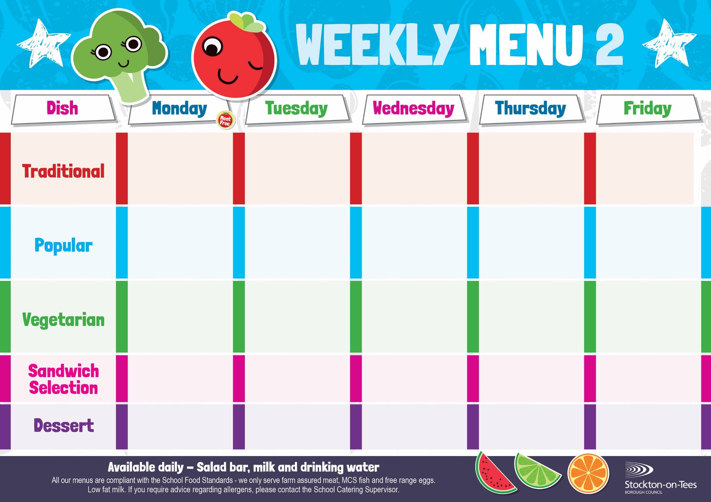
Quorn Bolognaise
Homemade Garlic Bread
Mixed Vegetables
Fish Fillet Fingers
Potato Wedges
Baked Beans

Oven Baked Chips
Garden Peas & Baked Beans

Pizza
Oven Baked Chips
Garden Peas & Baked Beans

Salmon & Sweet Potato Fishcake
Roasted Potatoes
Baked Beans
Sweetcorn

Jacket Potato filled with Tuna

Quorn Burger
in a Bun
Roasted Potatoes
Baked Beans
Sweetcorn

Tomato Pasta Bake with
Homemade Garlic Bread
Garden Peas
Weeks beginning - 12th January, 2nd February , 2nd March & 23rd March, 2026

Jacket Potato filled with
Cheese
Baked Beans

Baked Sausages
Mixed Vegetables

Roast Ham

Baked Jacket Potato

Jam Sponge &
Custard Sauce
Crispy Cake
Homemade Biscuit &
Fresh Fruit

Creamy Rice Pudding &
Jam Sauce
Ice Cream
Homemade Biscuit &
Fresh Fruit
Bakewell Tart &
Custard Sauce
Jelly Whirl
Homemade Biscuit &
Fresh Fruit
Vanilla Sponge &
Custard Sauce
Chocolate Brownie
Homemade Biscuit &
Fresh Fruit
Fish Goujons
Oven Baked Chips
Garden Peas
Baked Beans

Beef Burger in a Bun Roasted Potatoes
Baked Beans
Sweetcorn

Chocolate Crunch &
Custard Sauce
Decorated Iced Sponge
Homemade Biscuit &
Fresh Fruit
Cheese
Oven Baked Chips
Cheese
Potato Wedges

Tuna Mayonnaise
Potato Wedges
App
Egg Mayonnaise
Roasted Potatoes

Margarita Pizza
Roasted Potatoes
Garden Peas
Baked Beans
Spaghetti Bolognaise
Homemade Garlic Bread
Mixed Vegetables

