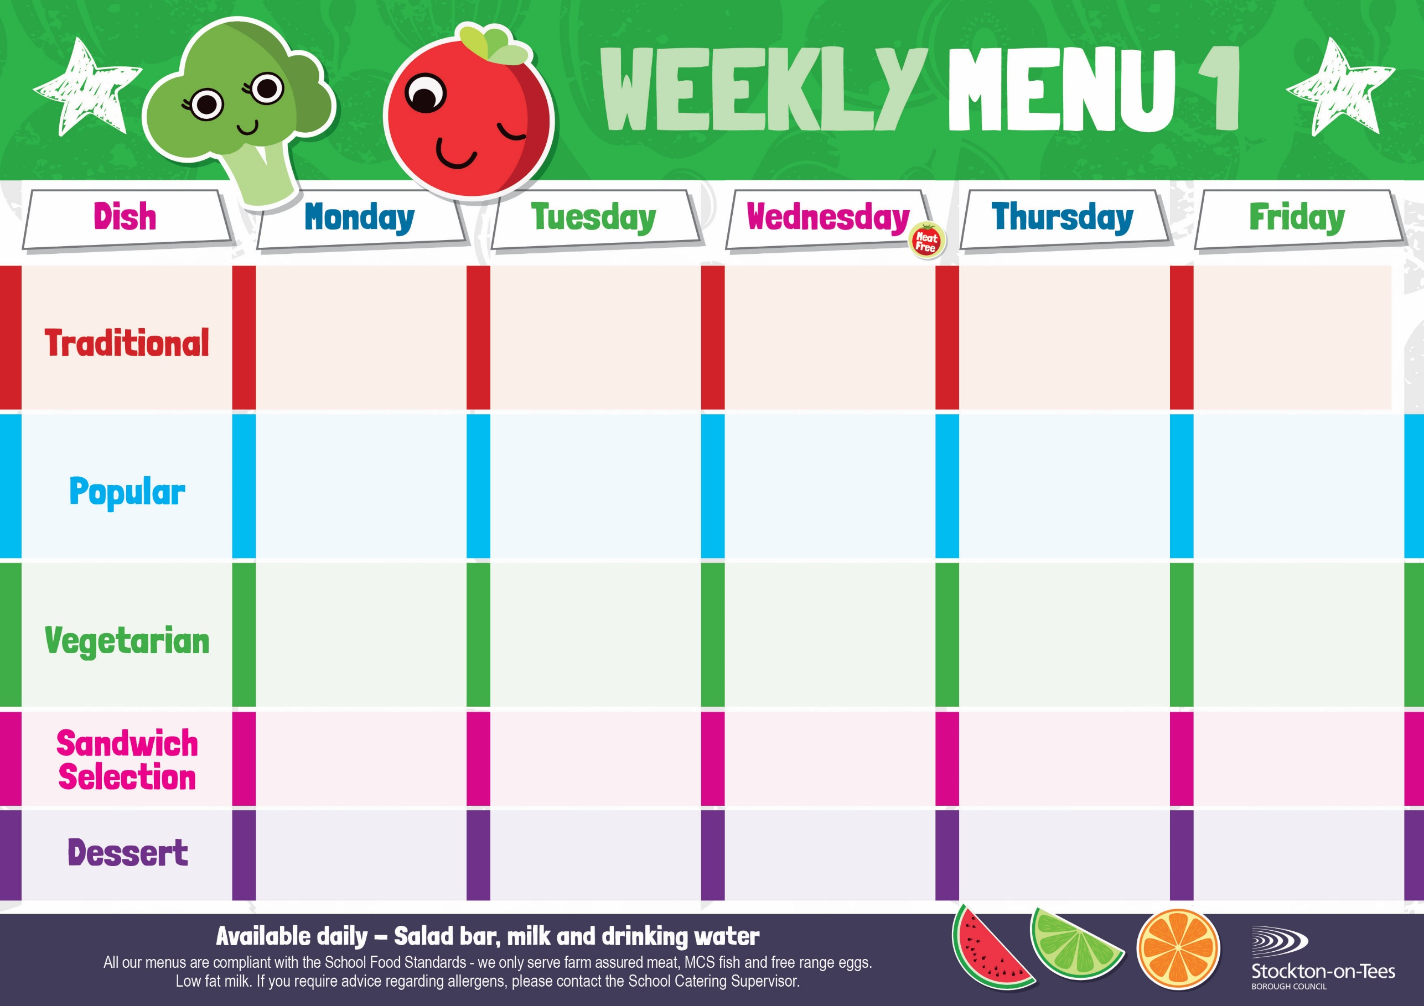

Baked Cheese Roll
Sausage roll
Roasted Potatoes
Garden Peas

Mini Cheese Slice
Potato Wedges
Baked Beans
Minced Beef & Dumplings
Creamed Potatoes
Cauliflower
Mixed Vegetables

Roast Turkey
Sage & Onion Stuffing
Creamed Potatoes
Broccoli & Carrots

Homemade Pizza
Oven Baked Chips
Mushy Peas
Baked Beans

Cheese Omelette
Baked Jacket Potato
Baked Beans

Oven Baked Chips
Mushy Peas
Baked Beans
Harry Ramsden
Fish Fillet
Oven Baked Chips
Mushy Peas
Baked Beans

Vegan Meatballs with Tomato Sauce
served with Pasta
Sweetcorn

Garlic Mushroom Pasta Bake with Homemade Cheesy Bread
Garden Peas

Cheese
Baked Jacket Potato

Tuna Mayonnaise
Potato Wedges
Tuna Mayonnaise

Baked Jacket Potato

Egg Mayonnaise
Roasted Potatoes

Weeks beginning - 5th January, 26th January, 16th February & 16th March, 2026

Decorated Iced Sponge & Custard Sauce
Ice Cream
Homemade Biscuit &
Fresh Fruit

Syrup Roly Poly &
Custard Sauce
Iced Bun
Homemade Biscuit &
Fresh Fruit

Chocolate Sponge &
Custard Sauce
Flapjack
Homemade Biscuit &
Fresh Fruit

Apple Crumble &
Custard Sauce
Jelly
Homemade Biscuit &
Fresh Fruit
Syrup Sponge &
Custard Sauce
Fruity Cookie
Homemade Biscuit &
Fresh Fruit
Cheese
Oven Baked Chips

Fish Cake
Baked Jacket Potato
Baked Beans

Pork & Carrot Meatballs with Tomato Sauce
served with Pasta
Sweetcorn

