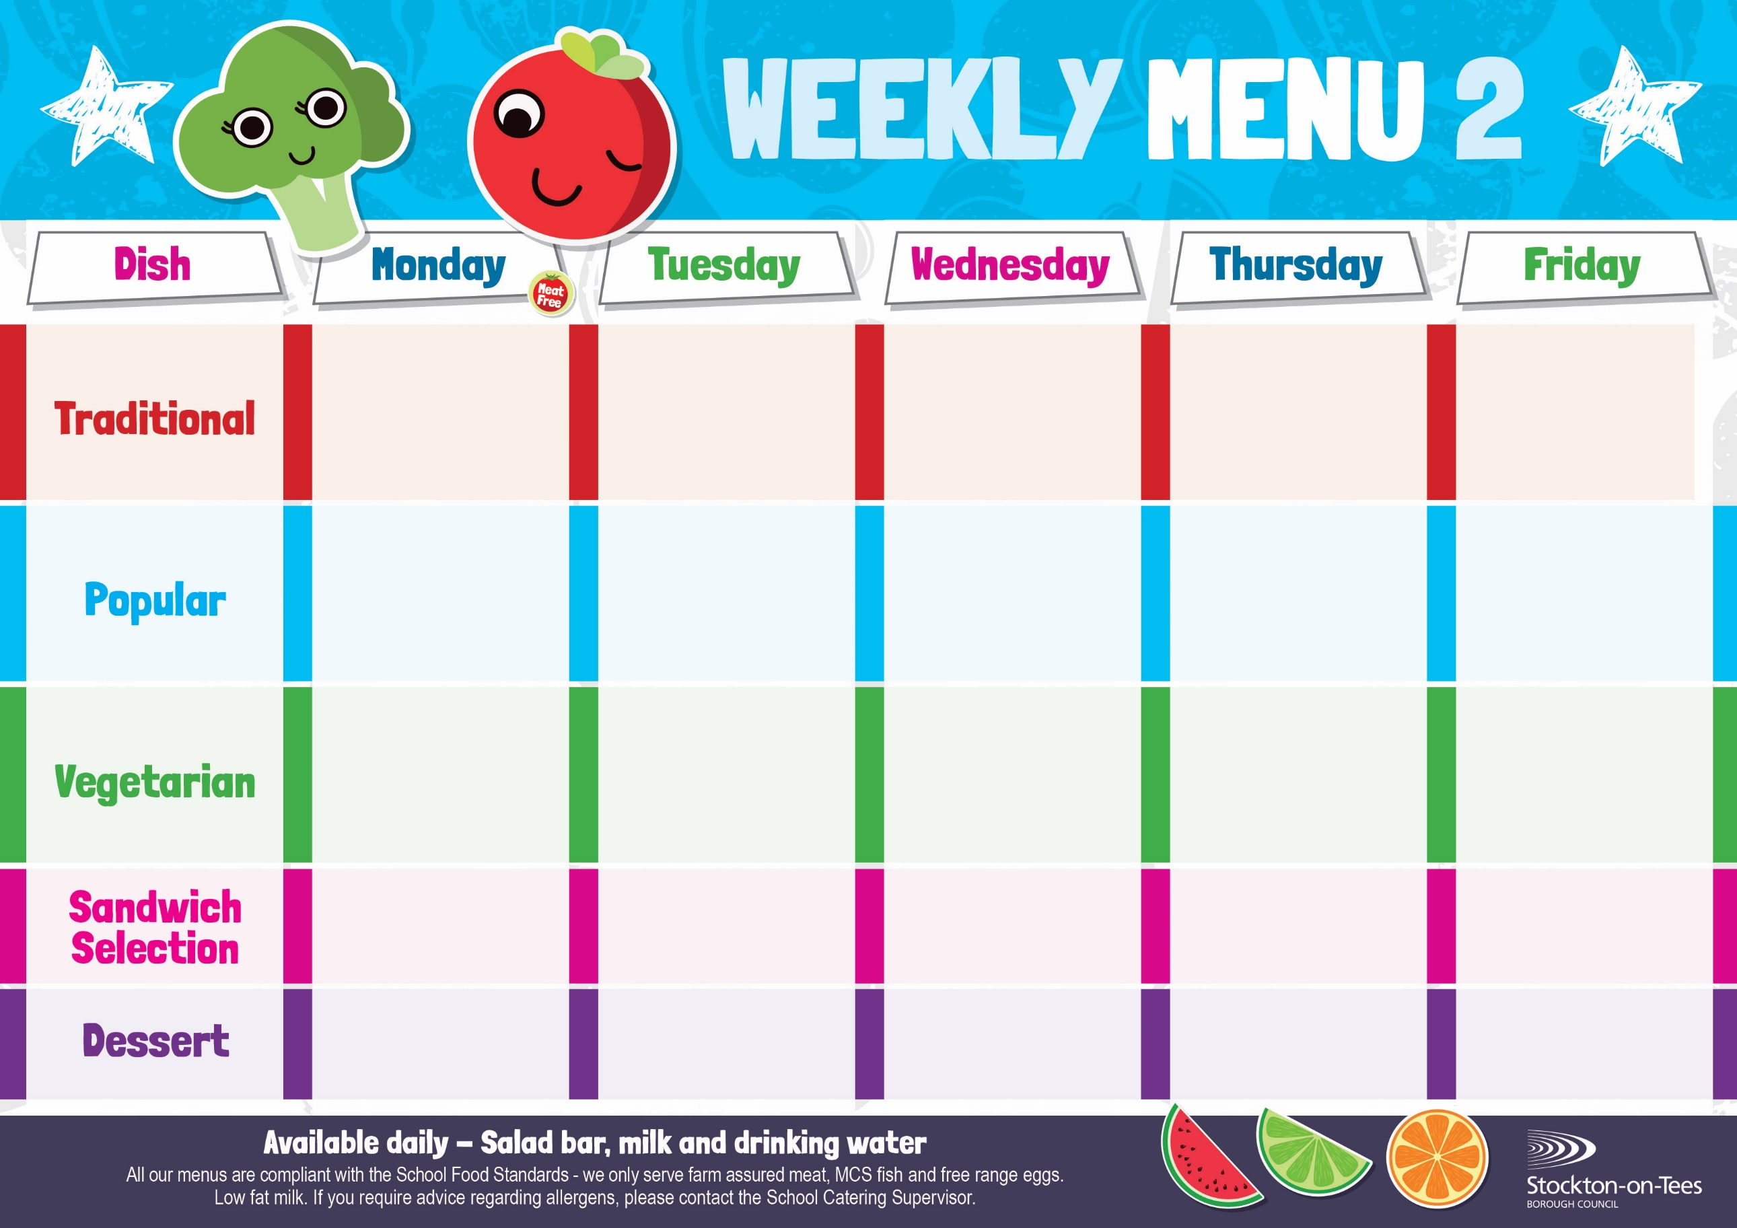

Pizza

Cheese Quiche

Oven Baked Chips

Garden Peas

Baked Beans

**Weeks beginning 8th & 29th September, 20th October, 17th November & 8th December, 2025**

Quorn Burger

in a Bun

Roasted Potatoes

Beans

Sweetcorn

Salmon & Sweet Potato Fishcake

Roasted Potatoes

Spaghetti Hoops

Sweetcorn

Beef Burger in a Bun Roasted Potatoes

Spaghetti Hoops

Sweetcorn

Cheese

Baked Jacket Potato

Macaroni Cheese

Homemade Herby Bread

Garden Peas

Quorn Bolognaise

Homemade Garlic Bread

Broccoli & Carrots

Diced Quorn Curry

& Rice

Mixed Vegetables

Mini Cheese Slice

Baked Jacket Potato

Spaghetti Hoops

Sausage Roll

Potato Wedges Baked Beans

Jam Sponge &

Custard Sauce

Jelly

Homemade Biscuit &

Fresh Fruit

Creamy Rice Pudding &

Jam Sauce

Ice Cream

Homemade Biscuit &

Fresh Fruit

Pineapple Upside Down Cake & Custard Sauce

Cup Cake

Homemade Biscuit &

Fresh Fruit

Vanilla Sponge &

Custard Sauce

Choc Chip Cookie

Homemade Biscuit &

Fresh Fruit

Fish Goujons

Oven Baked Chips

Garden Peas

Baked Beans

Spaghetti Bolognaise

Homemade Garlic Bread

Broccoli

Carrots

Chocolate Crunch &

Custard Sauce

Decorated Iced Sponge

Homemade Biscuit &

Fresh Fruit

Tuna Mayonnaise

Oven Baked Chips

Tuna Mayonnaise

Potato Wedges

Roast Ham

Baked Jacket Potato

App

Egg Mayonnaise

Roasted Potatoes

Homemade Pizza

Roasted Potatoes

Garden Peas

Baked Beans

Chicken Curry & Rice

Mixed Vegetables