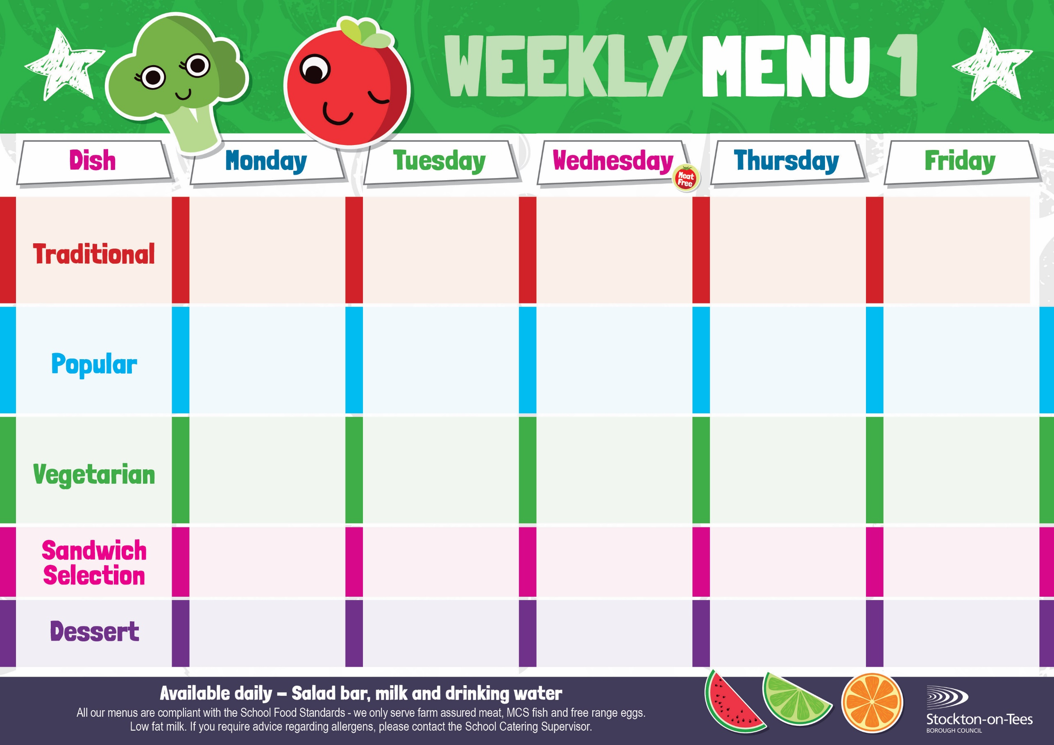

Baked Quorn Sausages

Roasted Potatoes

Sweetcorn

Baked Beans

Homemade Pizza Oven Baked Chips

Garden Peas &

Baked Beans

Penne Pasta in Tomato Sauce

Homemade Garlic Bread

Garden Peas

Roast Ham

Roasted Potatoes

Cheese

Potato Wedges

Tuna Mayonnaise

Baked Jacket Potato

Baked Jacket Potato with Cheese or Baked Beans

Fish Fillet Fingers

Potato Wedges

Spaghetti Hoops

Egg Mayonnaise

Roasted Potatoes

**Weeks beginning** **1st & 22nd September, 13th October, 10th November & 1st December, 2025**

Creamy Rice Pudding &

Jam Sauce

Ice Cream

Homemade Biscuit &

Fresh Fruit

Syrup Roly Poly &

Custard Sauce

Iced Bun

Homemade Biscuit &

Fresh Fruit

Ginger Sponge &

Custard Sauce

Fruity Cookie

Homemade Biscuit &

Fresh Fruit

Apple Crumble &

Custard Sauce

Fruity Muffin

Homemade Biscuit &

Fresh Fruit

Choc Chip Sponge &

Custard Sauce

Jelly Whirl

Homemade Biscuit &

Fresh Fruit

Egg Mayonnaise

Oven Baked Chips

Cheese Omelette Roasted Potatoes

Sweetcorn

Baked Beans

Harry Ramsden

Fish Fillet

Oven Baked Chips

Garden Peas &

Baked Beans

Minced Quorn Pie

Creamed Potatoes

Carrots

Cabbage

Baked Sausages

Roasted Potatoes

Garden Peas

Baked Beans

Roast Turkey with Sage & Onion Stuffing

Creamed Potatoes

Broccoli & Swede

Cheese roll

Roasted Potatoes

Baked Beans

Sweetcorn

Minced Beef Pie

Creamed Potatoes

Carrots

Cabbage