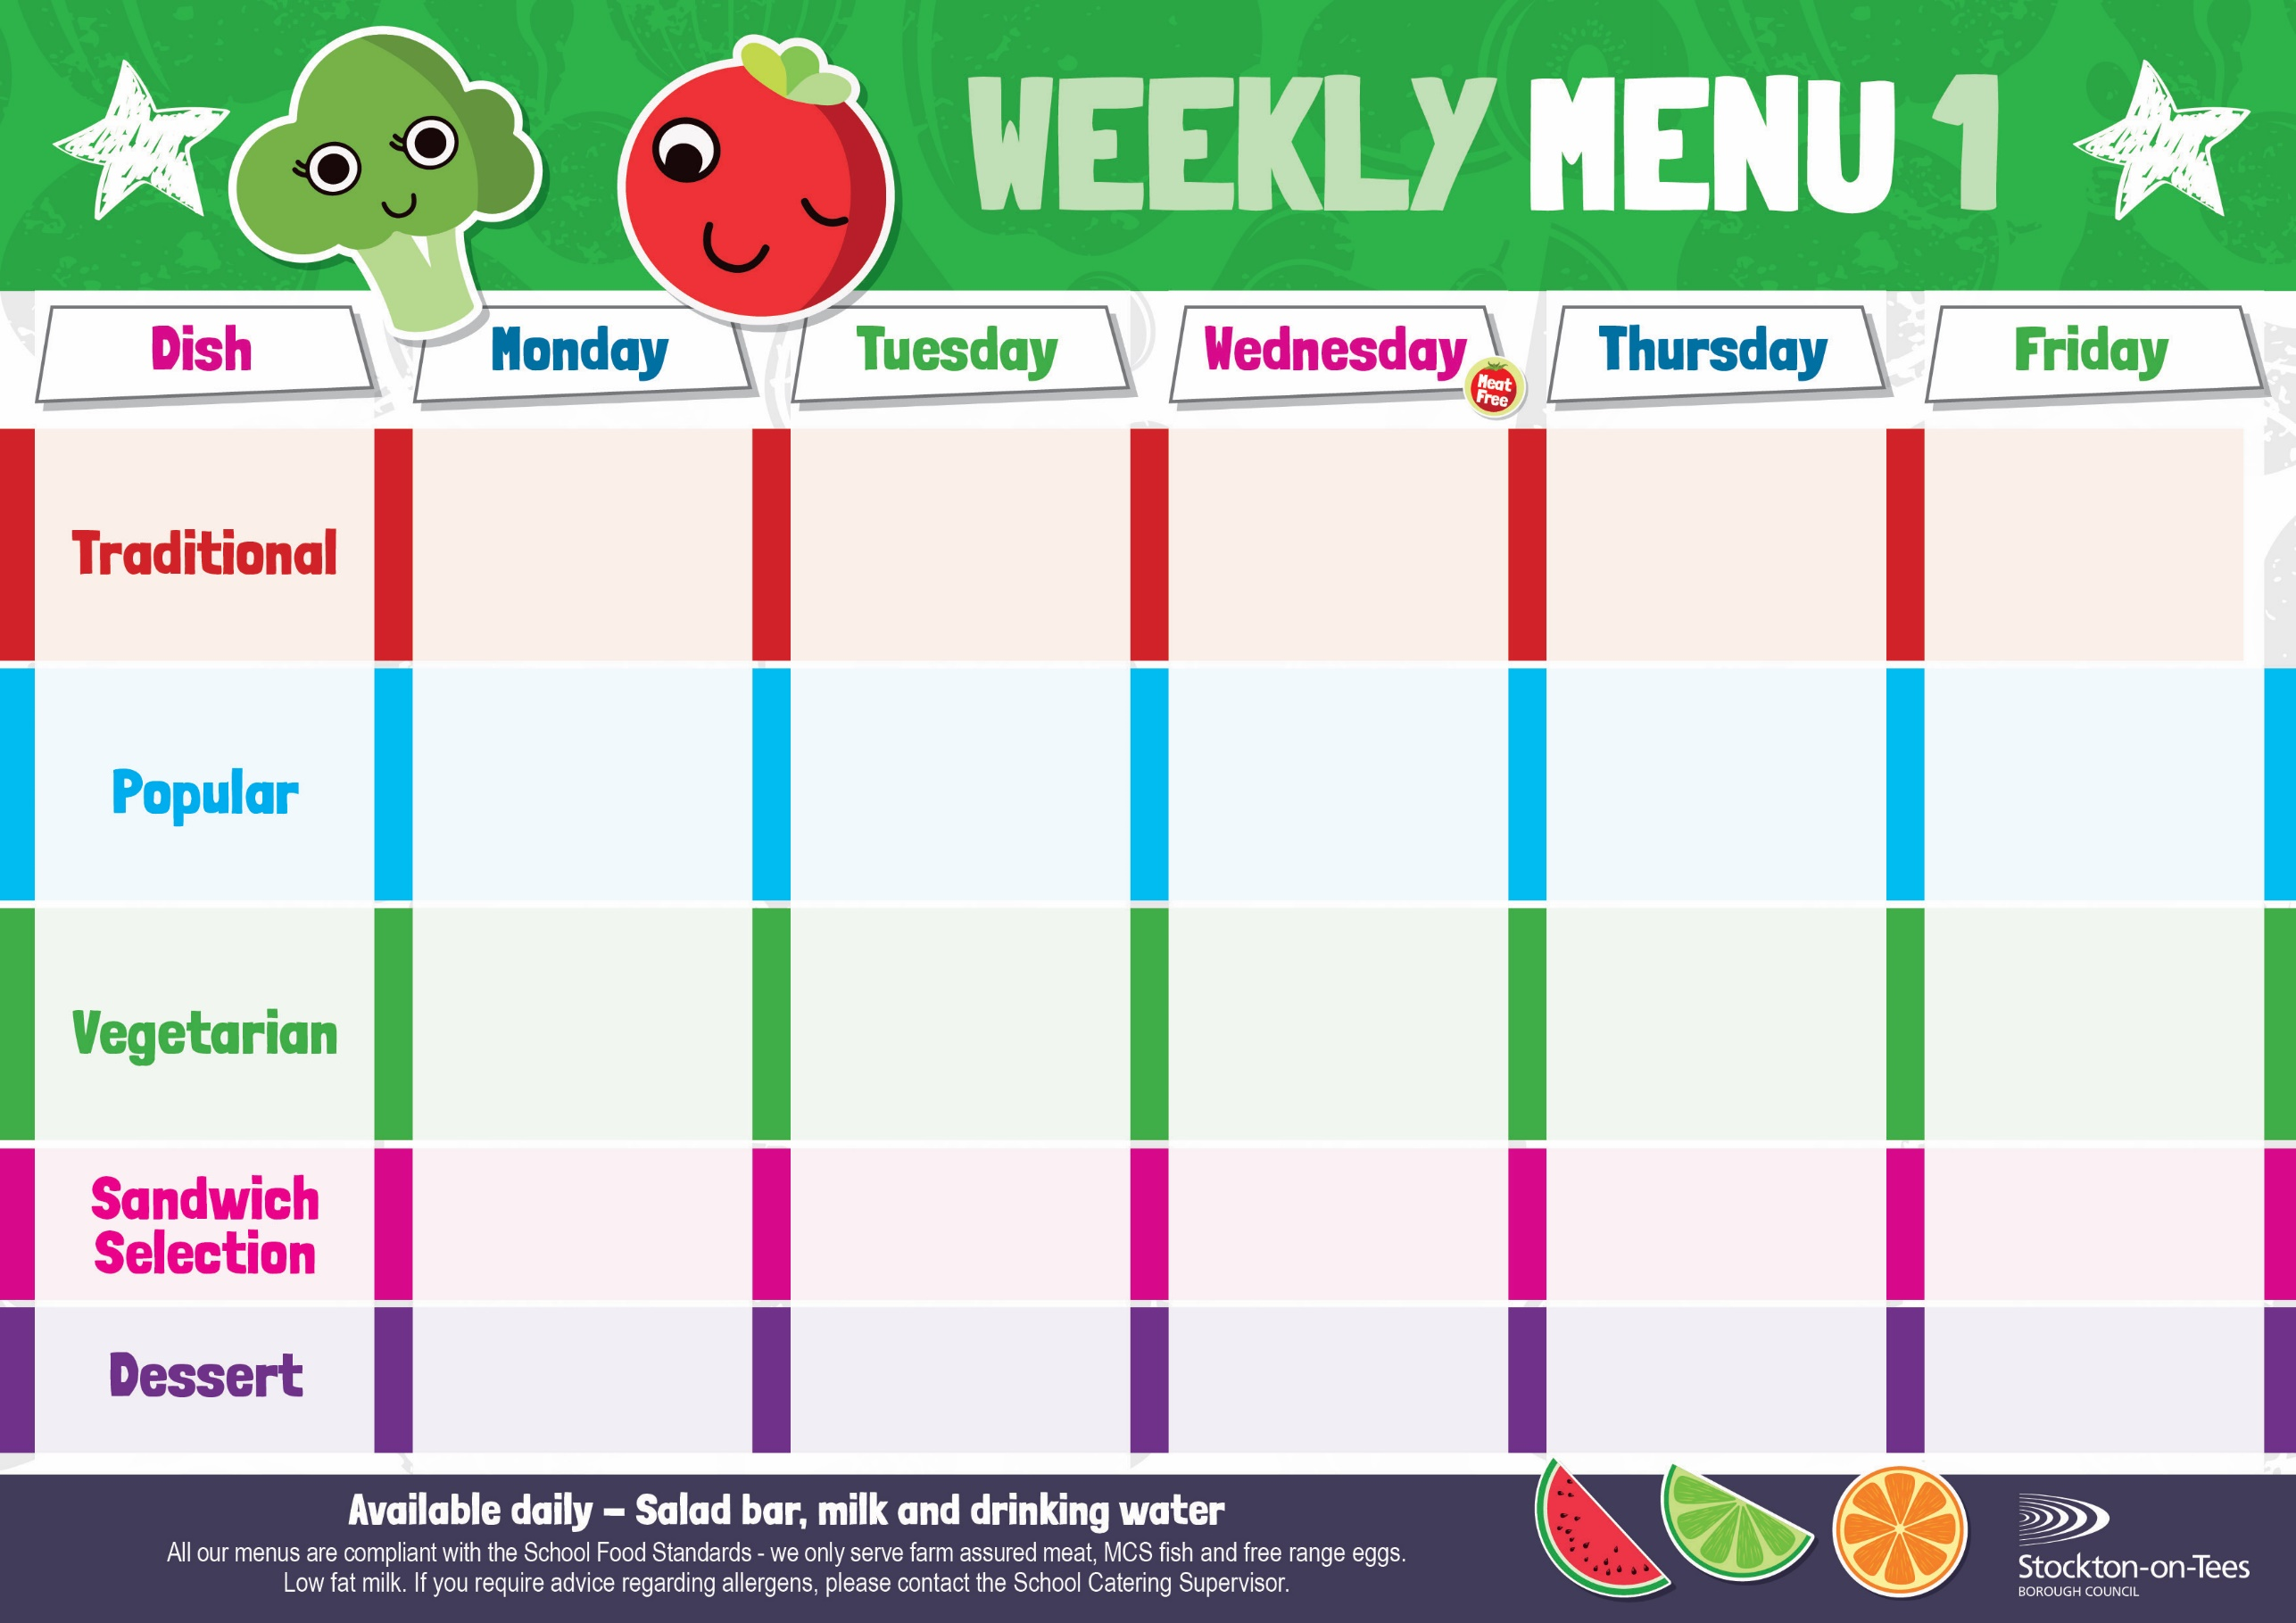

Cheese

Potato Wedges

Tuna Mayonnaise

Baked Jacket Potato

Baked Cheese & Onion Roll

Baked Jacket Potato

Spaghetti Hoops

Cheese Omelette Roasted Potatoes

Baked Beans

Sweetcorn

Fish Fillet Fingers

Potato Wedges

Spaghetti Hoops

Egg Mayonnaise

Roasted Potatoes

**Weeks beginning** **28th April, 19th May, 26th June & 7th July, 2025**

Creamy Rice Pudding &

Jam Sauce

Ice Cream

Homemade Biscuit &

Fresh Fruit

Syrup Roly Poly &

Custard Sauce

Iced Bun

Homemade Biscuit &

Fresh Fruit

Marble Sponge &

Custard Sauce

Fruity Cookie

Homemade Biscuit &

Fresh Fruit

Apple Crumble &

Custard Sauce

Fruity Muffin

Homemade Biscuit &

Fresh Fruit

Jam Sponge &

Custard Sauce

Jelly Whirl

Homemade Biscuit &

Fresh Fruit

Roast Ham

Oven Baked Chips

Pizza

Garden Peas

Tuna Mayonnaise

Baby Boiled Potato

Baked Jacket Potato with Tuna

Harry Ramsden

Fish Fillet

Oven Baked Chips

Garden Peas &

Baked Beans

Quorn Casserole & Dumplings

Creamed Potatoes

Mixed Vegetables

Cauliflower

Baked Jacket Potato with Cheese or Baked Beans

Baked Sausages in Gravy

Baby Boiled Potatoes

Carrots & Green Beans

Roast Beef with Yorkshire Pudding

Creamed Potatoes

Broccoli & Swede

Homemade Pizza

Roasted Potatoes

Baked Beans

Sweetcorn

Chicken Casserole & Dumplings

Creamed Potatoes

Mixed Vegetables

Cauliflower