William Cassidi C of E Primary

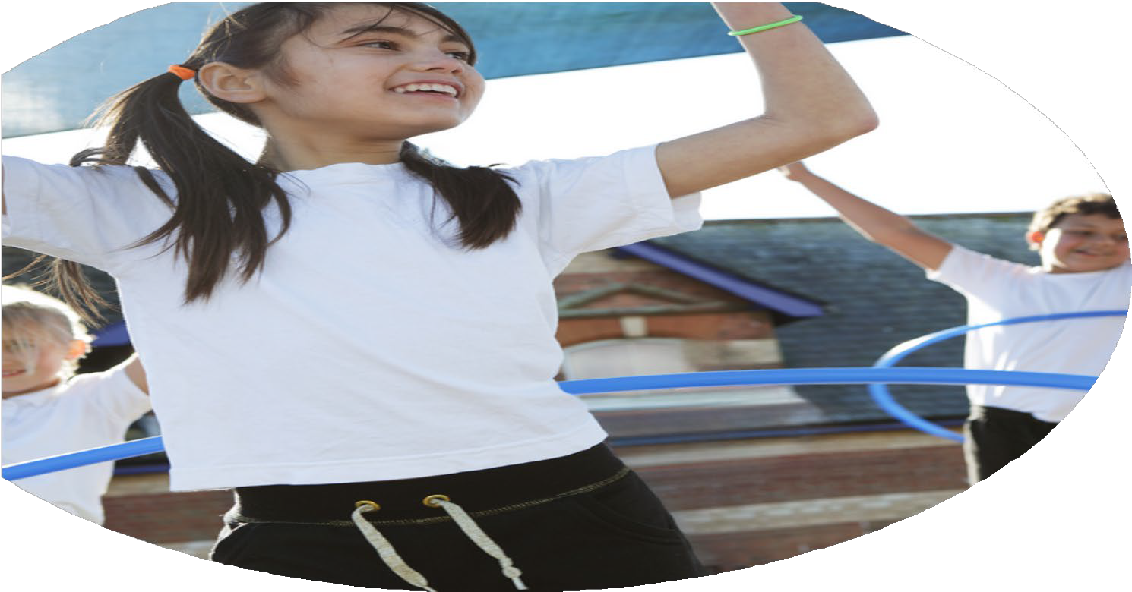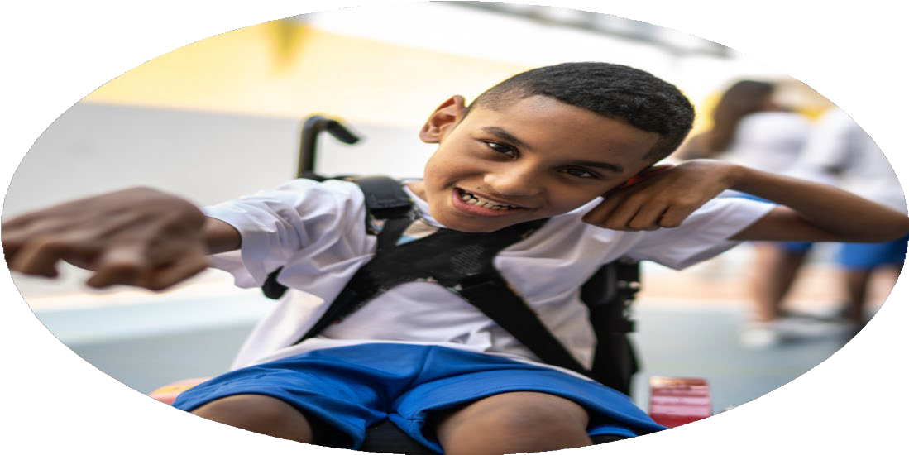

PE Funding Evaluation Form

2023/2024 and 2024/2025

**School Vision**

At William Cassidi Church of England Primary School our vision is to provide children with the very best education. To let them experience ‘life in all its fullness’ and living with all their heart. Our main core value of love underpins all that we do. Our school is Christ-centred and our core Christian values of love, respect, courage, service and resilience flow through every aspect of school life. It is on this bedrock that we provide an excellent education for the children who attend our school. We want every child to be the very best that they can be and to recognise that they are precious, loved and valued.

|  |  |  |  |
| --- | --- | --- | --- |
| **What went well?** | **How do you know?** | **What didn’t go well?** | **How do you know?** |
| The extra swimming allocations (catch up) in KS2 ensured that a higher proportion of pupils were able to swim over a distance of 25 metres unaided. | 100% of Y6 pupils leaving primary school achieved their water safety certificates.  80% of Y6 pupils leaving primary school were able to swim a distance of over 25 metres unaided. | The opportunities to utilise physical education opportunities during school playtimes and lunchtimes did not go as well as they could have. This will be a target moving int the 24/25 academic year and beyond. | Pupil and staff voice indicated a desire to have more structured activities – particularly linked to sports during playtimes and lunchtimes. Children were given more opportunities to develop gross motor skills in the summer months via fixed equipment on the field. They were not given as many opportunities in the winter months when field access was restricted. |

|  |  |
| --- | --- |
| **What are your plans for 2024/2025** | **How are you going to action and achieve these plans?** |
| **Intent** | **Implementation** |
| Total amount awarded **£17,400.00**  Our school vision is for children to live a ‘life in all fullness’. We therefore want to ensure that we provide an equity of provision to all children. We have listened to pupil and staff voice from the previous academic year and intend to ensure children have greater opportunity for outdoor learning, play and sports during social times and within the curriculum. We will use our sports premium funding in the following ways:   1. We will maintain the additional top up swimming lessons as this has been a strength in previous years. **£4,200.00** will be allocated for ‘top up’ lessons to ensure children achieve water safety and can swim beyond 25 metres unaided by the end of Y6. **£1500.00** will be used to fund swimming transport. 2. Maintain the Y6 outdoor education residential to Robinwood. Sports premium to be used to fund transport - **£600.00** 3. Complete CPD on an ‘Opal Play’ model and purchase the necessary resources so that pupils can independently access equipment during break times and lunch times. Create an ‘outdoor provision’ on the playground. Appoint pupil playground leaders. **£2000.00** 4. Offer a sports based after school club each week for the duration of the academic year. Ensure there is no additional cost to pupils so that all children can access for equity of provision: Autumn term (dance), Spring term (Gym) and Summer term (Cricket).   **£3000.00**   1. Continue to participate in competitive sporting competitions with other Stockton Primary Schools. This will enable children to gain more off-site and competitive experiences. **£1600.00** SLA. **2000.00** transport. 2. Increase the amount of sports based educational visits beyond SLA competitions e.g. visits to local parks for outdoor orienteering, EY beach camps to develop gross motor skills, etc… **£1000.00** including transport. 3. Maintain the annual Sports and Fitness week in school and ensure there is opportunity for specialist coaches/provision. Ensure children have access to activities they may not necessarily have access to in the local area e.g. climbing walls, skateboarding, etc… **£1000.00**   Total monies allocated: £16,900.00  Reserves for replenishment of resources/equipment  (maintenance): £500.00 | 1. Additional top up of swimming funding to be maintained. Sept 2024 onwards. Immediate implementation. 2. Maintain the Y6 outdoor learning residential. Funds allocated for transport in Sept 2024. PP funding to be used to financially support any vulnerable/disadvantaged pupils for equity of provision. 3. Embed the updated EY outdoor provision completed in July 24. Use this as a modelled example. Complete CPD on an ‘Opal Play’ model in the Autumn term. Gather pupil and staff voice linked to activities. By Spring term purchase the equipment/resources and begin to implement so that children can independently access during social times. In the Spring term request donations from the school community to transform the playground into an outdoor learning provision, which provides opportunities for outdoor learning, play and greater access to sporting/structured activities. 4. Create an extra-curricular timetable for the academic year in September and share with the school community. Range of sports activities. In a bid to ensure children ‘live a life in all fullness’ offer an activity that maybe quite costly to attend privately such as Ballroom and Lain American dance ad possibly something that they may not otherwise encounter. 5. Sign up to the sports SLA with Stockton local authority in September 2024. Ensure PE lead attends the training session in January 2025 and events are put into the calendar one term ahead. Ensure a range of activities are experienced for a rich diet of sporting events. Ensure a range of year groups access competitive events. 6. Organise all educational visits at the start of the academic year and publish to parents and carers on class overview sheets. Ensure there is an outdoor adventure entitlement in educational visit offer. 7. In April 2025 the HT and PE lead will sit and plan the timetable for sports and fitness week. |

|  |  |
| --- | --- |
| **What impact/intended impact/sustainability are you**  **expecting?** | **How will you know? What evidence do you have or**  **expect to have?** |
| Children will ‘experience’ a greater participation in sporting activities – including activities that they may not normally have the courage to try or opportunity to access. This will ensure our school vision is ‘lived’. Children will have a ‘full’ and ‘rich’ variety of sporting experiences.  A greater sense of play will be evident from children and the opportunity for greater exercise opportunities during playtimes and lunchtimes. This will positively impact learning behaviours in lessons as pupils will have been physically active for a continuous 50 minute block. | A record of all sporting activities participated in throughout the year, which will exceed historical lists in terms of variety and number of pupils impacted. This can be used as comparative data from one year to the next.  Pupil and staff voice will capture the impact of break time and lunch time provisions. Learning behaviour data from PM lessons will be analysed to review the impact of more movement during break times on pupil learning behaviours and focus. |

|  |  |
| --- | --- |
| **What impact/sustainability have you seen?** | **What evidence do you have?** |
|  |  |